The Wealthy Captain: Your Guide to Becoming One

JOEL SCHOFER, MD, MBA, CPE, FAAEM, FAAPL
CAPT, MC, USN
Copyright © 2025 Joel Schofer, MD, MBA, CPE, FAAEM, FAAPL
All rights reserved.
ISBN:

The views expressed in this publication are those of the author and do not necessarily reflect the official policy or position of the Department of the Navy, Department of Defense, or the United States Government.

DEDICATION

To my wife Wendy and my children, Erin and Nicholas, a supportive and understanding family, which is the key to a successful Naval career.

CONTENTS

 | Acknowledgments | i
1 | The Foundation | 1
2 | Stay Out of Trouble and Avoid “Red Flags” | 4
3 | Actively Manage Your Career and Record | 9
4 | Volunteer to Help | 52
5 | Save At Least 20% | 54
6 | Invest Aggressively | 56
7  8  9  10 | Crush the TSP  The G Fund  7 Steps to Financial Freedom  Conclusion | 59  69  73  88

ACKNOWLEDGMENTS

The number of people who have contributed to this reference is innumerable. To all of them, I simply say, “Thank you.”

I owe special thanks to the various senior leaders who at one point or another created an educational product on fitness reports that somehow wound up in my e-mail inbox and remains on my laptop hard drive. I incorporated their wisdom into this product. These leaders include HMCM(r) Keith Barth, CAPT(r) Brendon Drew, CAPT(r) Joel Roos, CAPT(r) George Schoeler, CAPT(r) Denise Weber, and CAPT(r) Kim Zuzelski. There are probably others I’m forgetting, and for that I apologize.

1 – THE FOUNDATION

How do you become a wealthy Captain? In my opinion, it is simple in concept but not always easy to execute. You:

- Stay out of trouble and avoid any “red flags” on your record.
- Actively manage your career and record.
- Volunteer to help your leadership whenever they need it.
- Save at least 20% of all your income for retirement.
- Invest as aggressively as you can tolerate.

Stay Out of Trouble and Avoid “Red Flags”

Staying out of trouble should be self-explanatory, but many people find themselves on the wrong end of non-judicial punishment or a court martial. Based on my experience, the most common things that get people in trouble include:

- Alcohol related incidents (ARIs), like driving under the influence (DUI)
- Arrests
- Command managed equal opportunity (CMEO) complaints
- Family or relationship problems
- Failed body composition assessment (BCA) or physical readiness test (PRT)
- Having a positive urine drug screen, most commonly from tetrahydrocannabinol (THC) or the improper use of prescription medications
- Inspector General (IG) complaints against them
- Reckless driving
- Sexual assault or harassment
- Theft, often at self-scanners
- Toxic leadership complaints
- Unauthorized absence
- Vaccine refusal

It probably goes without saying that you need to do everything you can to avoid these situations throughout your career. For example, if you need help with alcohol use, get it before it affects your career.

There are some things on this list, though, that are practically unavoidable if you hang around long enough. For example, I’ve had CMEO and IG complaints against me and I no longer worry about them. I simply do whatever I think is right and deal with whatever comes down the road. If you lead in fear of things like this, you are not really leading. You are likely getting stepped on if not trampled all over.

What’s the bottom line? Do what you can to avoid “red flags”, so they don’t adversely affect your career.

Actively Manage Your Career and Record

During promotion boards at Navy Personnel Command (NPC) in Millington, Tennessee, you may hear this statement, “Officers don’t get promoted, records do.” It is true. They are not looking at you as a person, they are looking at your record. For this reason, it is imperative that you maintain the accuracy of your record and deliberately work to improve it.

Your record consists of:
- A summary of your career known as your Officer Summary Record (OSR).
- A summary of your fitness reports (FITREPs) known as your Performance Summary Record (PSR).
- Your actual FITREPs and other documents like awards and diplomas in your Official Military Personnel File (OMPF).

Currently, promotion board members are required to review the last five years of your FITREPs, but your entire record is available for review. Boards will occasionally delve into FITREPs and other portions of an officer record that fall outside of this five-year window.

Because your record plays such a prominent place at promotion boards, you need to prioritize maintaining its accuracy. The earlier in your career you start, the better. Trying to rush things three weeks before your first in zone look at O6 is not the best course of action. Personally, I started very early, and I review my entire record every time I receive a new FITREP. This ensures I look at it at least once a year. I’d encourage you to do the same or set up another way to make sure you review it annually.

The system in which officer records are housed is prone to errors and more complicated that it needs to be. The Navy is trying to make it simpler, but it is still a work in progress. Much of my professional career has been built trying to make sure it is as easy as possible for officers to update their record. If you are in the Dental, Medical Service, Medical, or Nurse Corps, the easiest way to update your record is to read chapter 3 of this book. Because things change, I’d strongly encourage you to use the most recent version, which can always be found here. It is very Medical Corps focused, largely because that is my Corps and the only type of promotion board on which I’ve had the chance to serve. I can’t tell you what is said in Dental, Medical Service, or Nurse Corps promotion boards because I’ve never been on one. That said, the mechanics of both the promotion boards and updating records are largely the same. If you read something in chapter 3 that is different for your Corps and are not sure what to do, your Detailer or Corps Chief’s Office at the Navy Bureau of Medicine and Surgery (BUMED) will likely know.

In addition to maintaining the accuracy of your officer record, you need to work to develop it as you progress in your career. Time is limited, and if you are faced with doing one thing versus another, I’d probably lean toward the one that directly improves your record over the one that doesn’t. We’ll discuss this more in the chapter about improving your record.

Finally, actively managing your career requires learning to interact with both your Specialty Leader, Detailer, and Corps Chief’s office. Luckily, I’ve been a Specialty Leader, Detailer, and Deputy Corps Chief, so we will talk more about this in Chapter 3.

Volunteer to Help Your Leadership Whenever They Need It

The number one ingredient to promote is receiving competitive Early Promote (EP) FITREPs. What is the easiest way to get them? When your leadership asks for help, raise your hand and volunteer to do whatever they need.

Most commands have constant turnover of personnel. This leads to a steady stream of leadership opportunities that need to be filled and are advertised via e-mail, in the Plan of the Day/Week, or electronically on something like SharePoint. In addition, there are Navy-wide opportunities that our usually put out by Detailers, your Corps Chief’s Office, and on MCCareer.org.

You need to regularly monitor these sources, and if something is available that fits your interests, talents, or career path, consider applying for it.

Save at Least 20% of All Your Income for Retirement

Track every dollar that enters your household, including not just pay but also allowances. Make sure you take a minimum of 20% of this total (more is certainly better if you can afford it) and invest it for retirement. Once it is put away for retirement, do not touch it. Leave it invested and continually add to it. This is how you become wealthy, which will give you options for early part-time work or retirement.

You will be constantly tempted by the financial media, periodic market crashes, and other things to tinker or deviate from this plan. Don’t! This is also how you become wealthy. You stick to your plan.

Invest as Aggressively as You Can Tolerate

You can become wealthy by investing in only one asset class, stocks. As you build wealth, you will most likely want to add some bonds to preserve your wealth. Cash is the asset class for your emergency fund and short-term spending needs. All asset classes beyond stocks, bonds, and cash are optional. These include real estate, commodities, cryptocurrency, and other alternative asset classes.

Early in your career, you should primarily invest in stocks. Your asset allocation can even be 100% in stocks, but everyone’s risk tolerance is different. Some reading this will lay awake at night worried about the daily changes in their portfolio with a 100% stock asset allocation. For these people, they should probably not have a 100% stock asset allocation but should add bonds and cash until they have de-risked to the point where they can sleep at night and leave their portfolio alone.

If you want to build wealth, though, you need to invest as aggressively as you can with as high a stock allocation as you can tolerate. That might be 100% or something less than that, but you want your stock allocation to be as high as you can tolerate.

Summary

To become a wealthy Captain, you need to take these five steps:

- Stay out of trouble and avoid any “red flags” on your record.
- Actively manage your career and record.
- Volunteer to help your leadership whenever they need it.
- Save at least 20% of all your income for retirement.
- Invest as aggressively as you can tolerate.

Let’s get into the weeds…

2 – STAY OUT OF TROUBLE AND AVOID “RED FLAGS”

To become a wealthy Captain, you need to stay out of trouble and avoid what I call “red flags” that permanently stain your officer record. Once you do acquire a red flag, it can be very difficult if not impossible to recover. Every year you don’t promote you are competing against more officers who do not possess any red flags, and that is what you are up against.

What are “Reg Flags”?

Based on my experience, the list includes:

- Alcohol related incidents (ARIs), like driving under the influence (DUI)
- Arrests
- Command managed equal opportunity (CMEO) complaints
- Family or relationship problems
- Failed body composition assessments (BCA) or physical readiness tests (PRT)
- Having a positive urine drug screen (UDS), most commonly from tetrahydrocannabinol (THC) or the improper use of prescription medications
- Inspector General (IG) complaints against them
- Reckless driving
- Sexual assault and harassment
- Theft, often at self-scanners
- Toxic leadership complaints
- Unauthorized absences
- Vaccine refusals

Let’s talk about each of these individually.

Alcohol Related Incidents (ARIs)

The Navy is very supportive of those with alcohol problems, but the career impacts are best minimized if you seek help before you have an ARI. Once you have an ARI, you will often have entered the legal process, acquired a “red flag” on your record, and have a fight ahead of you. The Drug and Alcohol Program Advisor (DAPA) and Substance Abuse Rehabilitation Program (SARP) available to you are likely to offer top quality programs to assist you, if needed.

Arrests

In my experience, most arrests are a result of ARIs, domestic violence, reckless driving, drug related charges, and theft. Lately, the temptation to steal things when self-scanning seems to be an issue as well.

CMEO Complaints

These typically arise when people feel like they are in a toxic work environment or are being treated unfairly. If the hair on the back of your neck ever starts to stand up, alerting you that you are going down this path, do what you can to address the issue early and at the lowest level possible. Hopefully you can address issues before a formal CMEO complaint is filed.

That said, if you lead for long enough, you will have complaints filed against you. Do what you think is right, treat people fairly, and don’t fear a complaint. It will happen to the best of us if we hang around long enough.

Family or Relationship Problems

Many Sailors find themselves embroiled in troubled relationships, but the Navy offers many services that can help. I’d check out the counseling services at Military OneSource, where you can find your local Fleet and Family Support Centers or other available counseling programs. The earlier you try to get help, the less impact these problems will have on your career.

Failed BCA or PRT

You probably have a sense of whether this is a risk for you. If it is, please use the resources available to you. First, unless you are in a remote deployment, there should be a fitness center somewhere. These centers usually offer fitness assessments and some nutritional guidance. In addition, many MTFs will have Dieticians or Nutritionists that can help you.

If you have a medical condition that could affect your ability to pass a BCA or PRT, get it documented and treated. Early in my career I was completely healthy and didn’t fully understand people who would come to medical just to get things documented in their record. Later in my career, I got a herniated disk in my neck that usually gives me torticollis for one or two weeks every year. If this happened at the wrong time, it could have affected my ability to pass a PRT, so I got an MRI and got it documented. I didn’t want to wake up the day of a PRT with torticollis and not have a legit reason for it.

I say again…do not ignore any physical ailment that could affect your ability to pass a BCA or PRT. Once you fail a BCA or PRT, you often have trouble promoting for five years because that failure is on your PSR and within the mandatory five-year FITREP review at promotion boards. Sometimes people can promote once they pass one or two cycles, but sometimes it takes the full five years until the failure drops outside the five-year window.

Positive UDS

Avoiding a positive UDS is simple. Do not:

- Use any drugs not permitted by Naval regulations.
- Take any prescription medications except as prescribed.
- Take medication prescribed for someone else.
- Take a medication that does not have a current prescription. Taking your opioid analgesics that were prescribed 4 years ago but do not have a current prescription will get you in trouble.
- Visit vape shops or hookah bars.
- Eat food unless you are sure you can trust its source, especially gummy bears and brownies.
- Eat or drink food with cannabidiol (CBD) or hemp products.

This can be especially challenging when traveling to places where marijuana is legal (although it remains illegal to use in the Navy).

What should you do if you believe you’ve been unintentionally exposed to a substance? I would immediately report it to your chain of command. If you believe you need it, seek medical attention. Hiding a suspected exposure and praying that you do not get selected for a random UDS is not a recommended strategy. Popping positive on a UDS and then trying to use an unintentional exposure as the reason has not worked out for multiple people I’ve seen.

IG Complaints

If you hang around long enough and ascend the leadership ladder, you will probably have multiple IG complaints levied against you. There isn’t much you can do to avoid it, so my simple advice is to:

- Understand and follow policy.
- If you don’t want to or can’t follow policy, get an exception to policy.
- Treat everyone as fairly as you can.
- Do what you think is right.

If you follow this advice, all you can do when you get an IG complaint is let the process play out and try not to worry about it too much. If you did the best you could to treat everyone fairly and consistent with policy, ultimately following the course of action you felt was right, there isn’t much more you can do.

Reckless Driving

I have seen a major increase in military personnel being charged with reckless driving, which sometimes involves jail time. In Virginia, it is defined as driving 20+ miles per hour over the speed limit or driving 85+ miles per hour or more. If you drive at excessive speeds, you could be threatening your career.

Sexual Assault and Harassment

Sexual assault and harassment are topics that are complex and beyond the scope of this book. If you find yourself a victim, get help or report its occurrence. If you find yourself accused, get legal assistance at your local legal services offices. You will probably need it.

Theft

I’ve seen both officers and enlisted personnel caught up in theft and larceny. Often the cases involve taking liberties at self-scanning stations. Avoid the temptation to join this crowd.

Toxic Leadership

If you experience toxic leadership, you should not tolerate it. Period. There are many avenues to get this handled. Off the top of my head, they would include:

- Including your comments in your command’s DEOCS survey, which is anonymous and will be seen by senior leadership that can do something about it.
- Approaching your chain of command directly about the issue.
- Filing IG or CMEO complaints. These definitively get investigated and addressed.

If you are accused of toxic leadership or suspect you may have tendencies toward that, you need to get help. There are many avenues available to help, depending on the specific scenario. They would include:

- Counseling
- Executive coaching, which is available privately at your expense but also currently offered by BUMED. Your Corps Chief’s Office can probably connect you if it is still available. Naval Postgraduate School also has similar executive services, but often at a cost (which your command may cover).
- Mental health services

Unauthorized Absences

It is your responsibility to know where and when you are to be at your place of duty. Most often officers find themselves in this situation when they are not able to respond when on duty or on call, or when they take leave to an unauthorized location and leadership discovers it.

For example, I know it is inconvenient to follow the procedures for OCONUS leave, but they exist for a reason. If you elect not to follow the policies and instead put your home address on your leave request but go somewhere else, that is on you if your command figures that out and goes after you.

Also, find a reliable way to note when you are on call so that you are, in fact, both sober and available during those time periods.

Vaccine Refusals

Numerous officers have found themselves in legal or administration proceedings, mostly due to the COVID-19 vaccination. If you find yourself debating whether to obtain a vaccine or not, I will simply encourage you to follow the current policy. If there is a process to get medically or religiously exempted from the vaccine, follow that procedure.

What to Do if You Get a Red Flag

If it is legal or you feel as if your career is threatened, get a lawyer from your local legal support.

If it is alcohol or substance related, get help from your local DAPA. Don’t try to hide your problem. Self-report if it is not too late.

If it could be improved by mental health or counseling services, get them.

In addition, develop patience. Some red flags can be overcome, and some cannot. Often you will need to wait a little, demonstrating you’ve overcome the issue while also waiting for any FITREPs that document it to fall outside of the last 5 years that they review at promotion boards.

3 – ACTIVELY MANAGE YOUR CAREER AND RECORD

During promotion boards at Navy Personnel Command (NPC) in Millington, Tennessee, you may hear this statement, “Officers don’t get promoted, records do.” It is true. They are not looking at you as a person, they are looking at your record. For this reason, it is imperative that you maintain the accuracy of your record and deliberately work to improve it.

Your record consists of:
- A summary of your career known as your Officer Summary Record (OSR).
- A summary of your fitness reports (FITREPs) known as your Performance Summary Record (PSR).
- Your actual FITREPs and other documents like awards and diplomas in your Official Military Personnel File (OMPF).

Currently, promotion board members are required to review the last five years of your FITREPs, but your entire record is available for review. Boards will occasionally delve into FITREPs and other portions of an officer record that fall outside of this five-year window. In this chapter we’ll first tackle your officer record from the perspective of preparing for a promotion board, then we’ll discuss individual FITREPs and career management.

PART 1 – PROMOTION BOARD PREPARATION

Because your record plays such a prominent place at promotion boards, you need to make maintaining its accuracy a priority. The earlier in your career you start, the better. Trying to rush things three weeks before your first in zone look at O6 is not the best course of action. Personally, I started very early, and I review my entire record every time I receive a new FITREP. This ensures I look at it at least once a year. I’d encourage you to do the same or set up another way to make sure you review it annually.

The system in which officer records are housed is prone to errors and more complicated that it needs to be. The Navy is trying to make it simpler, but it is still a work in progress. Much of my professional career has been built trying to make sure it is as easy as possible for officers to update their record. If you are in the Dental, Medical Service, Medical, or Nurse Corps, the easiest way to update your record is to use this chapter. It is very Medical Corps focused, largely because that is my Corps and the only type of promotion board on which I’ve had the chance to serve. I can’t tell you what is said in Dental, Medical Service, or Nurse Corps promotion boards because I’ve never been on one. That said, the mechanics of both the promotion boards and updating records are largely the same. If you read something here that is different for your Corps and are not sure what to do, your Detailer or Corps Chief’s Office at the Navy Bureau of Medicine and Surgery (BUMED) will likely know. Also, please e-mail me at jschofer@gmail.com and let me know so I can add it.

Getting Started

The first thing you need to do is download PDF copies of your Officer Summary Record (OSR), Officer Data Card (ODC), and Performance Summary Record (PSR). Follow the thick red arrows below for the step-by-step guide to get these documents.

Go to BUPERS On-Line (https://www.bol.navy.mil/). Click on the CAC login button.

Now click on the “ODC, OSR, PSR, ESR” link.

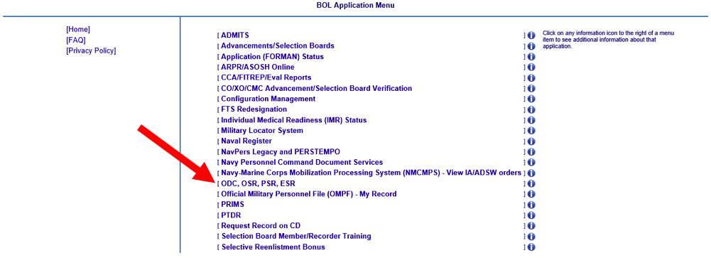

You’ll need to click on all three of these links highlighted by the red arrows to get all three documents you will need. Click on the “Officer Summary Record (OSR)” link first.

After clicking on the OSR link, you’ll see this screen. Click where the red arrow points to advance to the next screen.

Now click on the button that will download the PDF for you.

You’ll need to repeat these last three steps for the PSR and ODC. Then you should have the three PDF files you need. If you experience problems accessing these items online, contact the My Navy Career Center at 1-833-330-MNCC (6622) or askmncc.fct@navy.mil.

Your Promotion Timeline

How do you know when you will be “in zone” for promotion? You cannot answer this question until mid-December when the official promotion zones are released. Usually within a few days after this, BUMED will circulate an Excel spreadsheet via your Corps Chief’s Office and Specialty Leaders. This spreadsheet will tell you if you are above zone, in zone, below zone, or not under consideration for the upcoming promotion boards.

What are your chances of promoting?

See the tables below for the actual promotion statistics for the Medical Corps for the last 10 years:

 | FY16 | FY17 | FY18 | FY19 | FY20 | FY21 | FY22 | FY23 | FY24 | FY25 | FY26
O4 | 100% | 100% | 100% | 100% | 100% | 100% | 95% | 95% | 95% | 100% | 99.5%
O5 | 70% | 65% | 75% | 85% | 77% | 77% | 90% | 90% | 94% | 95% | 95%
O6 | 50% | 70% | 80% | 90% | 81% | 91% | 90% | 95% | 90% | 90% | 94%
Medical Corps promotion opportunity. This percentage is multiplied by the zone size to give the number of officers to be selected for promotion. For example, if the promotion opportunity is 90% and there are 100 officers in-zone, then 90 will be selected for promotion. This 90, however, may come from officers who are below-zone, in-zone, or above-zone. For example, maybe 60 of the 90 are in-zone, and 30 are below or above-zone. That is why the percentage of people in-zone who are selected for promotion is always lower than the promotion opportunity. See below…

 | FY16 | FY17 | FY18 | FY19 | FY20 | FY21 | FY22 | FY23 | FY24 | FY25 | FY26
O4 | 93% | 88% | 85% | 87% | 91% | 83% | 91% | 88% | 83% | 89% | 84%
O5 | 53% | 44% | 40% | 52% | 53% | 50% | 50% | 57% | 61% | 71% | 72%
O6 | 39% | 34% | 37% | 41% | 51% | 53% | 60% | 67% | 65% | 69% | 73%
Actual percentage of in-zone Medical Corps candidates selected for promotion.

If promotion board math is still confusing, this post breaks it down in more details.

Now that you’ve downloaded the PDFs of your record and understand your timeline, let’s get started updating your record. If you want me to look at your record, you can submit it here.

Awards

The first thing you need to do is ensure that the awards listed on your OSR are accurate. This is where the promotion board will see them, and where promotion board recorders will make updates, as required. If you look on your OSR and your awards are accurate, you are done. Only individual awards at the level of a Navy and Marine Corps Achievement Medal (NAM) or higher will show here. Unit awards are not displayed. For example, here is what mine looks like (of note, I don’t have any NAMs):

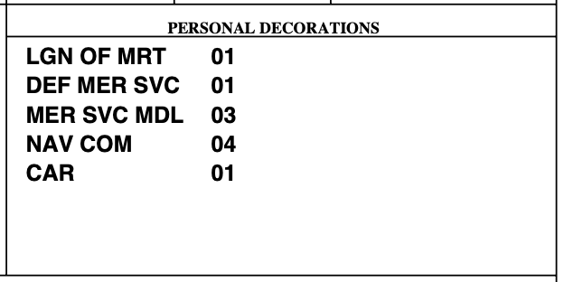

If the awards on your OSR are not accurate, you will need to log on to BOL and follow the instructions on the awards webpage at Navy Personnel Command.

If you are still confused after reading this page, here are my recommendations for simplified and practical steps to take if the awards on your OSR are not correct:

- Recognize that the awards section of your OSR is of very little importance unless you have a Combat Action Ribbon, Bronze Star, Purple Heart, or other combat award. It also might be important if you have an award that is atypical for your rank (for example, an O5 with a Legion of Merit or an O4 with a Meritorious Service Medal) or have fewer awards than one would expect at your rank (an O5 up for O6 with only a NAM). Getting credit for your 3rd Navy Commendation is not going to be the difference in whether you do or do not promote.
- Contact the awards person in your admin shop to see if they can help you fix the issue.
- Contact the My Navy Career Center at 1-833-330-MNCC (6622) or askmncc.fct@navy.mil. They can often fix award problems or at least tell you what you need to do.
- If that doesn’t work, just send a letter to the promotion board discussing the corrections that are necessary. This won’t fix your record permanently, but it will ensure the awards were accurate for that board. Letters are discussed later in this chapter.

Your PSR

You need to ensure your FITREPs are accurate on your PSR. First, make sure there are no gaps in your FITREP continuity. To check on this, logon to BOL.

Next, click on the link entitled “CCA/FITREP/Eval Reports”.

Then click on the link entitled “Performance Evaluation Continuity Report”.

A report will be generated that lists all your FITREPs and at the bottom of the screen shows you if there are any gaps that you will need to address. As you can see, there are no gaps in my FITREPs.

Focus especially on the last five years of FITREPs because that is what the promotion board will focus on. If you have gaps, you can ignore any that are 90 days or less in duration. If you have more than a 90-day gap, you should try to get it addressed, and often you’ll just have to send a letter to the promotion board to explain the gap. Old FITREP issues are hard to get fixed.

If there are significant gaps or errors, try to get them corrected by contacting My Navy Career Center at askmncc.fct@navy.mil or by phone at 1-833-330-MNCC (1-833-330-6622). Your Detailer cannot fix FITREP issues or errors themselves.

Sending duplicate FITREPs compounds any processing problem that might exist, so it is best to call and check on the report first. If a FITREP is missing from your record, you may have to send a copy signed by the member and the reporting senior to:

Bureau of Naval Personnel
PERS-32
5720 Integrity Drive
Millington, TN 38055‐3201

Only do this AFTER contacting My Navy Career Center to ensure that they have not already received the report.

If you are just trying to change the dates of a FITREP to close a gap, requests for administrative changes can be requested by letter to PERS‐32 (address above). Members can request corrections of obvious errors to blocks 1‐19 and blocks 21 to 27 by submitting a letter requesting the corrections to PERS‐32. Changes to other blocks on the FITREP must be requested by the reporting senior that signed the original report.

If you can’t get gaps 90 days or greater corrected before the promotion board, just send a letter to the promotion board to explain them. Procedures for sending a letter to the board are discussed later in this chapter.

One last thing on your PSR…you need to make sure the info recorded on the PSR for your FITREPs is accurate. There is no easy way to do this other than to manually review your FITREPs. While the entire record is available for review, if you just can’t get yourself to review all your FITREPs you can perhaps just review the last five years since that is what the promotion board will focus on. All the boxes you need to check and what they mean are explained here:

If you are still having trouble interpreting your PSR, this blog post may help.

Academic Degrees

You need to ensure all educational degrees are present on your OSR and are accurate. Here you can see my degrees. They include a BS from 1997 in Exercise & Sports Science and Biology from Ursinus College in Pennsylvania, an MD in 2001 from Hahnemann in Pennsylvania, and an MBA in 2014 from Naval Postgraduate School in Monterey (click here for a blog post about how degrees like this one can you promoted).

To have your formal education updated, the official transcripts must come directly from the school to the office below. They can be delivered electronically if the school uses a secure delivery system such as eScript/Parchment to askmncc.fct@navy.mil or they can be mailed to:

NAVY PERSONNEL COMMAND
MNCC
BLDG 768 RM E302
5720 INTEGRITY DRIVE
MILLINGTON, TN 38055

If you are going to send them electronically, please note this caveat from the PERS website:

“Transcripts sent electronically through National Student Clearinghouse must select “Education Organization, Application Service and Scholarships”, “Department of the Navy” and “Navy Personnel Command” in the drop-down menus of the recipient details section. Selecting other options may result in failure to deliver transcripts electronically.”

If you note duplicate degrees on your OSR, you can correct them by contacting My Navy Career Center at askmncc.fct@navy.mil or by phone at 1-833-330-6622. I had a duplicate degree, and they fixed it very quickly on my record.

Please also note this Q&A from the PERS website:

My board is coming up soon and I need to update my record with transcripts. Will my transcripts make it in time?

Answer: It is recommended that any record update completed within 1 month of your board convening date should also be followed up with a letter to the board with the same information.

Additional Qualification Designators (AQDs)

Ensure all the additional qualification designation codes (AQDs) that you qualify for are in block 72 of your ODC. Here is what mine looks like:

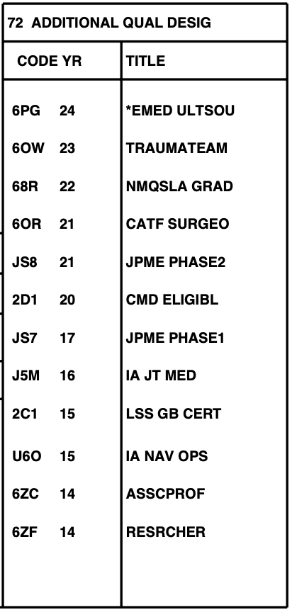

What are AQDs? Here is a post that answers exactly that question. Your AQDs feed the “Special Qualifications” section of your OSR, which is what the promotion board will see. They don’t see your ODC.

Here is what my Special Qualifications section looks like. You can see that many reflect the AQDs that I have:

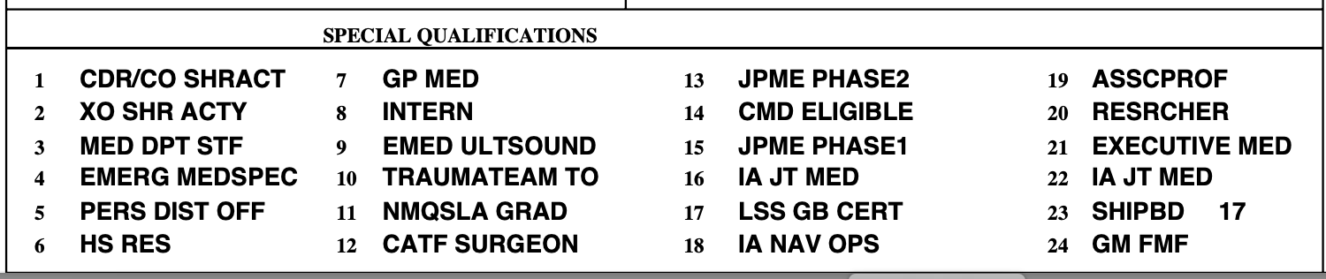

The other way that this Special Qualifications section gets populated is the billets you occupy. For example, there is no AQD for my #5 Special Qualification “PERS DIST OFF” (short for Personnel Distribution Officer). To get this qualification you must have resided in a Detailer billet for six months.

To see which AQDs you qualify for, go to this blog page for a list of all medical AQDs. The list of non-medical AQDs is more than 600 pages long and may be found on this blog page.

To make life easier for us and to prevent most physicians from having to look through 600+ pages to make sure they have every AQD they qualify for, I did a study of every Naval physician in December 2014 and looked at their non-medical AQDs. While you can obviously still go through all 600+ pages if you want, the list of non-medical AQDs that physicians often qualify for includes:

AQD CODE | NAME | REQUIREMENT
LA7 | Surface Warfare Medical Department Officer | Officer who has qualified as a Surface Warfare Medical Department Officer IAW OPNAVINST 1412.8.
BX2 | Fleet Marine Force (FMF) Warfare Officer | Qualified as a Fleet Marine Force Warfare Officer (FMFWO) IAW current fleet instructions and SECNAVINST 1412.10.
U6O | Operations Intra Service IA | Successfully completed assignment to an Individual Augmentation (Intra Service) for a minimum period of 6 months.
U4M | Fleet/Division Staff Medical Intra Service IA | Successfully completed assignment to an Individual Augmentation (Intra Service) for a minimum period of 6 months.
U6M | Other Medical Intra Service IA | Successfully completed assignment to an Individual Augmentation (Intra Service) for a minimum period of 6 months.
BT1 | Static-Line Qualified Parachutist | Officer who is qualified IAW MILPERSMAN 1220-030.
QK1 | Naval Special Warfare Experience | Non-SEAL/SWCC Officer who completes 15 months or more service in a qualifying Naval Special Warfare billet.
J6M | Other Medical IA | Successfully completed assignment to an Individual Augmentation (Interservice Interagency Coalition) for a minimum period of 6 months.
J4M | Fleet/Division Staff Medical IA | Successfully completed assignment to an Individual Augmentation (Interservice Interagency Coalition) for a minimum period of 6 months.
J5M | Joint Task Force Medical IA | Successfully completed assignment to an Individual Augmentation (Interservice Interagency Coalition) for a minimum period of 6 months.
J3M | Combatant Commander Level Medical IA | Successfully completed assignment to an Individual Augmentation (Interservice Interagency Coalition) for a minimum period of 6 months.
DZQ | Joint Air Operations | Course completion: Aviation Safety Officer course.

Once you have a list of medical AQDs you qualify for, e-mail the three letter codes, the year you qualified, and “proof” that you qualify for them (letters, FITREPs, transcripts, certificates, etc.) to your Detailer. The Detailer will add them to your record. Non-medical AQDs, such as those from a prior career as a line officer, are to be referred to that community’s Placement Officer. You’ll have to try and find them by going to each community’s page, which you can find along the left side of this page. Perhaps your Detailer could help you out as well.

As an aside, please try to put all this info into one e-mail to your Detailer. Detailers get a ton of e-mail, and it is much appreciated if all the AQDs you want added can be wrapped up into one nice, tidy e-mail package.

Note #1 - If you have done Joint Professional Military Education (JPME) I or II and are looking to add the JS7 (JPME I) or JS8 (JPME II) AQDs, here are the instructions to use because Detailers cannot add these AQDs:

Except for the "in-residence" military programs, you must provide us with your official JPME completion letter/diploma for all accredited programs to receive your respective AQD (JPME I - JS7, JPME II - JS8). Send your documentation for all distance learning programs to the appropriate email address below. Please redact all PII information. Documents are processed daily; however, you will not receive a reply that your email was received.

AC and FTS: AC_JQS_Manager@navy.mil
SELRES: Mill_RC_JQS_Manager@navy.mil
Your AQD will be entered in the Joint Manpower Information System, and Officer Assignment Information System within 30 days.

Note #2 - When it comes to AQDs, in my experience there are only a few that people mention when briefing a record at the promotion board. The ones mentioned are JPME I and II and any that represent a warfare pin or deployment. Outside of these, rarely do AQDs get mentioned. If you are looking to maximize your impact, spend your time getting JPME and your respective operational AQDs and ignore the rest of them.

Subspecialty Codes

You need to make sure that your record accurately reflects your board certification, training status, and specialties. On your OSR under “Education” is a section called “SUB-SPEC.” Here is mine:
In this section are cryptic codes that indicate what specialties you are trained in and whether you are board certified. The codes are listed below, and anything you are board certified in should end in the letter “K.” If it ends in “J” it means you are trained but not board certified. If it ends in a “T” it means you are in training for that specialty, like a residency or fellowship program.
15A0 | Flight Surgery
15A1 | Residency in Aerospace Medicine
15B0 | Anesthesia, General
15B1 | Anesthesia, Subspecialty
15C0 | Surgery, General
15C1 | Surgery, Subspecialty
15D0 | Neurosurgery, General
15D1 | Neurosurgery, Subspecialty
15E0 | OB/GYN, General
15E1 | OB/GYN, Subspecialty
15F0 | General Medical Officer
15G0 | Ophthalmology, General
15G1 | Ophthalmology, Subspecialty
15H0 | Orthopedics, General
15H1 | Orthopedics, Subspecialty
15I0 | ENT, General
15I1 | ENT, Subspecialty
15J0 | Urology, General
15J1 | Urology, Subspecialty
15K0 | Preventive Medicine, General
15K1 | Preventive Medicine, Subspecialty
15K2 | Occupational Medicine
15L0 | PM&R, General
15L1 | PM&R, Subspecialty
15M0 | Pathology, General
15M1 | Pathology, Subspecialty
16N0 | Dermatology, General
16N1 | Dermatology, Subspecialty
16P0 | Emergency Medicine, General
16P1 | Emergency Medicine, Subspecialty
16Q0 | Family Medicine, General
16Q1 | Family Medicine, Subspecialty
16R0 | Internal Medicine, General
16R1 | Internal Medicine, Subspecialty
16T0 | Neurology, General
16T1 | Neurology, Subspecialty
16U0 | Undersea Medicine, General
16U1 | Undersea Medicine, Subspecialty
16V0 | Pediatrics, General
16V1 | Pediatrics, Subspecialty
16W0 | Nuclear Medicine
16X0 | Psychiatry, General
16X1 | Psychiatry, Subspecialty
16Y0 | Radiology, General
16Y1 | Radiology, Subspecialty
16Y2 | Radiation Oncology

Using the above chart, you can see that my 16P0K is because I am board certified in Emergency Medicine. If I was in Emergency Medicine residency, my code would be 16P0T. My 16P1J is because I am fellowship trained in a subspecialty (Emergency Ultrasound) for which there is no board certification (which is why it ends in a “J”). When I was in fellowship, it would have been 16P1T.
To fix any of these subspecialty codes you e-mail CDR Tatiana Crosby at tatiana.crosby.mil@health.mil.
Make sure that if you are board certified in a specialty that AT LEAST ONE OF YOUR SUBSPECIALTY CODES ENDS IN A “K”. If you don’t, the promotion board may not be sure if you are board certified, and this is a near requirement in the Medical Corps if you want to be competitive for promotion to O5 and O6. It comes up at just about every promotion board.
Service Schools

Make sure the service schools listed on your OSR are accurate and up to date. Only six service schools will fit on your OSR. Here is what mine look like:

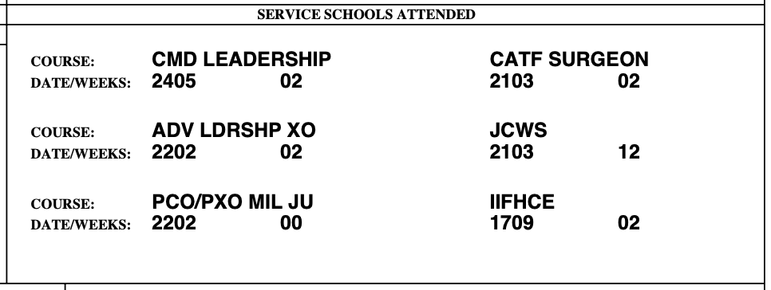

To see a list of service schools, go to this blog page. No matter how important you think a class is, if it is not a service school it cannot be added to the OSR.

To add a service school to the OSR, the three-digit service school code, course abbreviation, completion date, and duration (weeks or “cc” if correspondence course) are required. The course completion certificate and this information must be sent to My Navy Career Center at askmncc.fct@navy.mil.

You will know they have received your request because you’ll get an e-mail from them and follow-on e-mails updating you on the status of your request.

Going to the website below may be one stop shopping to obtain “proof” of your prior training as you can download a PDF copy of your training transcript:

https://jst.doded.mil/jst/

Letters to the Board

You should send a letter to the promotion board if:
- You are reporting to a new command, you will not receive a FITREP before the promotion board meets, and your reporting senior is willing to write a letter about your contributions to your new command.
- You have issues in your record or career that require explanation or amplifying information. For example, you want to tell the promotion board how promotion will allow you to do something you can’t do at your present rank, like screen for XO. If there are any gaps of more than 90 days in your military service or any new information not on your FITREPs, these may need explanation as well.
- You must make corrections/additions to your record (like missing or illegible FITREPs, awards, academic or professional achievements, etc.) but you either don’t have time to update them the standard way or you have tried without success. My general advice is to try fixing an issue twice. If after two attempts it is still not fixed, just send a letter to the board explaining that you tried to fix your record but could not. This won’t fix your record permanently and you’ll still have an incorrect record after the board, but it will keep you sane and ensure that your record was correct for that specific board.
- If you have been passed over for promotion at least once and you have testimonial letters from someone who can comment positively on your performance. In general, you should try to get letters from the most senior member who knows you well enough to discuss your contributions to the Navy and why you should get promoted. For example, it is probably better to get a letter from an O6 who knows you well than to get a letter from an O8 who does not. Also, your reporting senior usually should not write a letter if they have done a FITREP on you as their opinion should be reflected in the FITREP, although it is ultimately up to them. Your Specialty Leader is always a solid choice as a letter writer.

When writing letters to the board, keep the following in mind:
- They are usually not recommended unless there is a reason to send a letter listed above. Do not send one just for the fun of it.
- Keep it to a minimum - one page or less plus enclosures - as boards must read everything sent to them and they are very busy.
- Do not send copies of publications.
- Only the service member can send the letter on their behalf. In other words, if you have a letter from an admiral, you need to send it to the board. Don’t have the admiral’s aide send it to the board directly. It will not be considered by the board.
- By law, a letter to the board must be considered. In other words, if you don’t want the board to discuss a topic, don’t mention it in a letter. If there is adverse information in your record, sending a letter discussing it may help if you have amplifying information to add. Then again, if it is something they might not have noticed, sending a letter discussing it ensures that they will notice it!
- If you do have something adverse, I usually recommend you ignore it the first time you are in zone. If you don’t promote, the next time I’d try to explain your side of the story and see what happens. If you don’t promote the second time, I’d just alternate between ignoring it and sending a letter about it. If you wanted to reverse those and explain it the first time but ignore it the second time, that is probably fine too. It really is up to you how you want to handle it, and there is no obviously correct answer.
- Your letter must arrive no later than 10 calendar days before the board convenes.

For an example letter to the board, see this website and click on “Sample Letter to the Board” on the right side of the page. It tells you how to prepare and submit your letter.

What is a “Don’t Pick Me” Letter? Why Would You Send One?
If you go to the Navy Active Duty Officer Promotions Page, you’ll find this at the bottom:
Sample “Don’t Pick Me” Letter to the Board
Removing the introductory portion, here is what the meat of this letter says:
- Per reference (a), please do not select me for promotion by the FY-[XX] [ActiveDuty Navy/Navy Reserve] [Grade] [Line/Staff Corps] [Competitive Category] Promotion Selection Board.
That’s it. All it says to the promotion board is, “Don’t pick me.”
Why would or should an officer send a letter requesting NOT to be considered by a promotion board? Here are a few reasons:
- You know that you are resigning and will not be joining the Reserves.
If you are just paying your time back and getting out, do your fellow officers a favor and remove yourself from consideration. It is hard enough to promote nowadays. Having one less person to compete with helps those who are willing to stick around. Yes, if you are picked and get promoted soon enough you could get some extra pay for a little while before you resign, but the general karma of letting someone else get the promotion may outweigh that financial benefit.
- You are an O4 or O5 who is retiring but you know that if selected for promotion you won’t accept it.
Why would someone not accept a promotion? Because a promotion to O5 or O6 obligates you for 3 more years if you intend to retire. And the Navy still isn’t letting anyone get out early. If you want to get out as fast as possible with a 20-year retirement, taking a promotion to O6 in year 18 may mean you must stick around until year 21 at least.
So…if #1 or #2 above are applicable, consider sending a “Don’t Pick Me” letter. Make sure, though, that you are 100% POSITIVE that nothing in your situation will change. Lots of people who think they are going to get out, not join the Reserves, or want to retire right at 20 years later change their mind.
How to Be Considered for Promotion if You’ve Been on Active Duty for Less Than 1 Year
Each fiscal year a promotion board NAVADMIN is released in December. If you are in-zone or above-zone for an upcoming promotion board but you’ve been on active duty for less than 1 year, you should read the NAVADMIN. For example, here is what the FY26 NAVADMIN says:
8. In-zone and above-zone eligible officers in the grades of chief warrant officer 2/3/4, lieutenant, lieutenant commander, and commander, whose placement on the active-duty list is within one year of the convening dates of these boards, are automatically deferred unless they specifically request to be considered. The officer may waive this deferment and request consideration for promotion, in writing, emailed to NPC_Officer_SELBD_Elig_Waivers.fct@navy.mil or mailed to:

Commander, Navy Personnel Command (PERS-802)
5720 Integrity Drive
Millington, TN 38055-0000
For in-zone and above-zone eligible line officers in the grade of commander, the request must be received by PERS-802 not later than 2359 CST 15 days prior to the convening date of the respective board. For in-zone and above-zone eligible staff corps officers in the grade of commander, in-zone and above-zone eligible line and staff corps officers in the grade of lieutenant commander and lieutenant, and in-zone and above-zone chief warrant officers, the request must be received by PERS-802 not later than 2359 CST 30 days prior to the convening date of the respective board. Specifically:
Selection To Convening Date Due Date / Time
Staff Corps Captain 11 FEB 25 11 JAN 25 / 2359 CST
Staff Corps Commander 5 MAY 25 5 APR 25 / 2359 CST
Staff Corps Lieutenant Commander 5 MAY 25 5 APR 25 / 2359 CST
What does this mean and why would it apply to you? Maybe you had prior service, you went to medical school, and now you’re a senior LT who is in-zone for LCDR right away. Maybe you did a civilian NADDS residency, and you are in-zone right away for LCDR (although people in NADDS sometimes promote while they are in the Reserves). There might be other situations that would put you in this position, like getting time-in-grade credit for other experience.
If you believe you are in this position, here is what I’d do:
- Confirm you are in-zone or above-zone. How can you do this? The easiest way if you are MC or DC is to use the chart in the early part of this chapter. Or you can read this blog post that explains how zones work for the various Corps.
- If you wish to be considered for promotion to LCDR, CDR, or CAPT, do what it says above. Send the letter simply requesting this. It can probably be a very short letter. There is no need to be verbose.
PART 2 – FITNESS REPORTS (FITREPS)

This portion is designed to help you efficiently write an excellent FITREP. Your FITREP is the most important tool for documenting your achievements and potential for promotion.

What Do You Need to Start?

Before you begin writing your FITREP, you’ll need to gather a few things. They include:

- Your last FITREP.
- If you have previously received a FITREP from this reporting senior and it was in your current rank, you’ll want your PSR so that you know his/her approximate reporting senior’s cumulative average (RSCA).
- A list of your accomplishments and collateral duties you’ve held since your last FITREP. This could be on a “brag sheet” (a document some commands require you to submit when doing your FITREP) or somewhere else you’ve chosen to track these items. For example, I use my CV for this. You can use whatever you want, but you need to find an efficient way to track this information that works for you.
- Dates for any significant periods of leave, transit time, temporary additional duty (TAD or TEMADD), deployments, or anything else that took you away from your command.
- A computer that can access NAVFIT98A.

Let’s get started…

The Administrative Blocks – Blocks 1-28

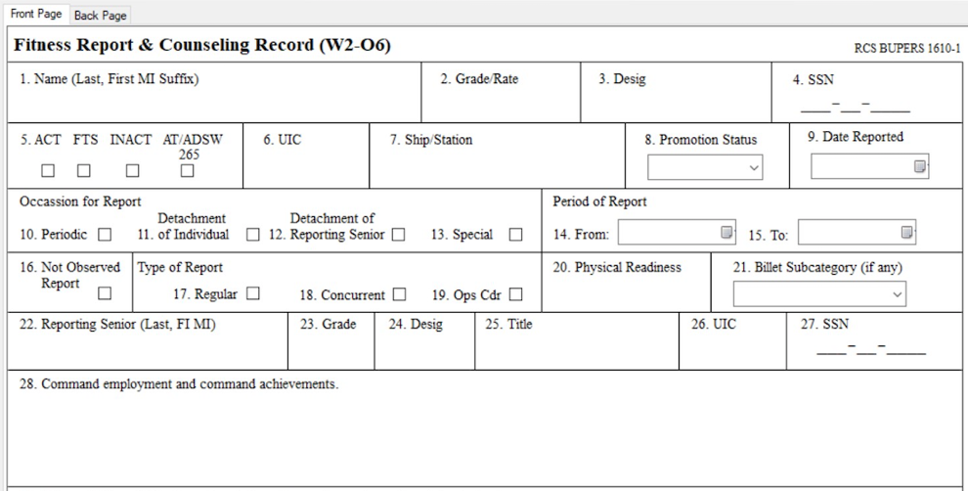
Figure 1 - Blocks 1-28 are administrative blocks.
Block 1 - Name
Enter your last name, first name, middle initial, and suffix, if any, separated by spaces. Place a comma after your last name. Omit spaces and punctuation within a name. The full middle name is acceptable but not required. Here are some examples:
- DENNEY, JOHN A
- STJOHN, MELVIN J II
- WALTERS, J ARTHUR
- OBRIEN, MARY S
- MARTIN, PAUL T JR
- SMITHJONES, ANN NMN
Block 2 – Grade/Rate
Enter the rank that you will be wearing on the ending date of the report.
Use the standard grade abbreviations (CAPT, CDR, LCDR, LT, LTJG, ENS). If you are a LTJG in the Medical or Dental Corps, you have a problem.
Block 3 – Designator
Enter your four-digit officer designator:
- Medical Corps – 2100
- Dental Corps – 2200
- Medical Service Corps – 2300
- Nurse Corps - 2900
Block 4 – SSN
Enter the full SSN in the format XXX-XX-XXXX for all reports that are going to be mailed.
Block 5 – Duty/Competitive Status
All active duty will check “ACT”.
Block 6 – Unit Identification Code (UIC)
Enter your UIC (not your reporting senior’s UIC, which may be different than your UIC), which you can get from block 98 on your ODC or your orders. For activities to which no UIC is assigned, enter five zeros. The first four characters of a UIC must be numbers.
Block 7 – Ship/Station
Get the abbreviated name of your command from an old FITREP. Make sure you put the name of the command where you are assigned, not your reporting senior’s command (if it is different). If you are assigned to a civilian or foreign command, enter the civilian or foreign command, not your administrative reporting senior’s command. Do not spell out letters and numbers (for example, use “A” and not “ALFA”, use “1” and not “ONE”).
Block 8 – Promotion Status
Here is the table from the FITREP instruction that details which of the various options to use:
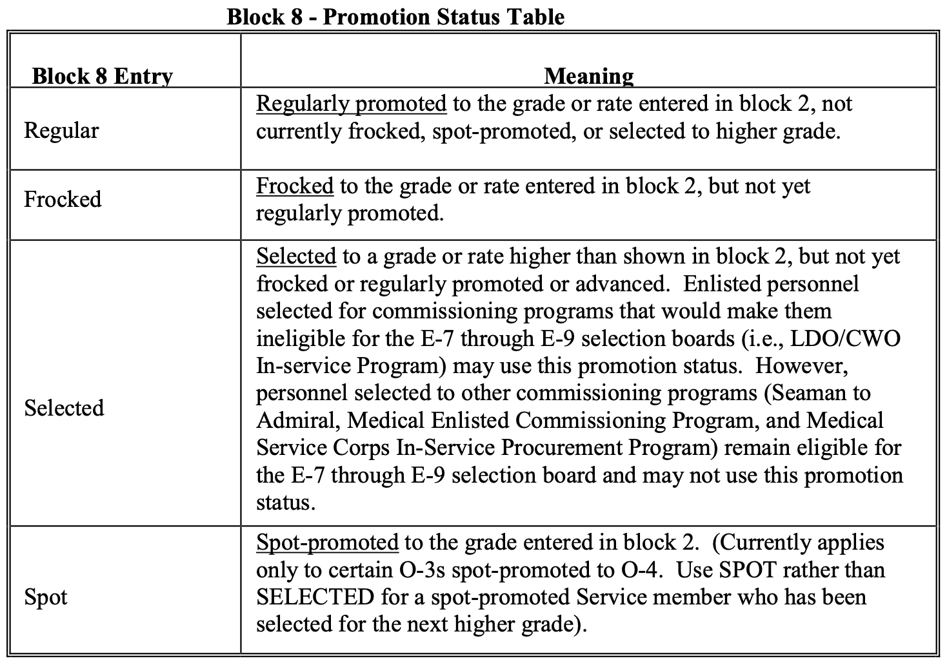
Most will probably be Regular unless you’ve been selected for promotion or frocked. I don’t know anyone that has been spot-promoted.
Block 9 – Date Reported
In YYMMMDD format or by selecting from the drop-down calendar, enter the date you reported to your command. For example, for October 17, 2024, you type “24OCT17”. The following formats are incorrect:
- 17OCT24
- 241017
- 101724

Blocks 10-13 – Occasion for Report
Place an “X” in each block that applies to this FITREP:
- “Periodic” – It is time for your regularly scheduled FITREP.
- “Detachment of Individual” – You are getting a FITREP because you are detaching from a command.
- “Detachment of Reporting Senior” – You are getting a FITREP because your reporting senior is detaching.
- “Special” – You are getting a FITREP for a special reason/circumstance.

Note: More than one occasion may apply, except that “Special” cannot be combined with another occasion. Do not submit a Special FITREP if another occasion applies.
Blocks 14-15 – Period of Report
In YYMMMDD format or by selecting from the drop-down calendar, enter the beginning (FROM) and ending (TO) dates of the reporting period. For example, for October 17, 2024, enter 24OCT17. The following are incorrect:

- 17OCT24
- 241017
- 101724

For regular reports, the FROM date must be the day following the TO date of the last Regular report. It can be earlier than block 9 (your reporting date) if there was en route leave, travel, or TAD.

For the first FITREP on a newly commissioned officer, the FROM date is the commissioning date. If the commissioning date has been back-dated, enter details in block 29 (i.e., commissioning back-dated to YYMMDD).

For the first FITREP on an enlisted member commissioned from officer candidate school, etc. the FROM date will start the day after the ending date of the last enlisted report.

Block 16 – Not Observed Report

If this is a wholly Not Observed (NOB) report, enter an “X” in block 16. The trait grades must be left blank, no career recommendation is permitted, the promotion recommendation must be NOB, and the promotion recommendation summary must be left blank. In addition, the Member Trait Average and Summary Group Average blocks must be left blank. Comments are limited primarily to administrative and training information.

Blocks 17-19 – Type of Report

Place an “X” in the block that applies. Most of the time it’ll be a Regular FITREP, unless you are deployed and then it'll be Concurrent. (If you are getting a concurrent report, read this post for tips to improve your FITREP.)

Block 20 – Physical Readiness

Enter the one-letter code for the result of each official physical fitness assessment (PFA) conducted in the reporting period.

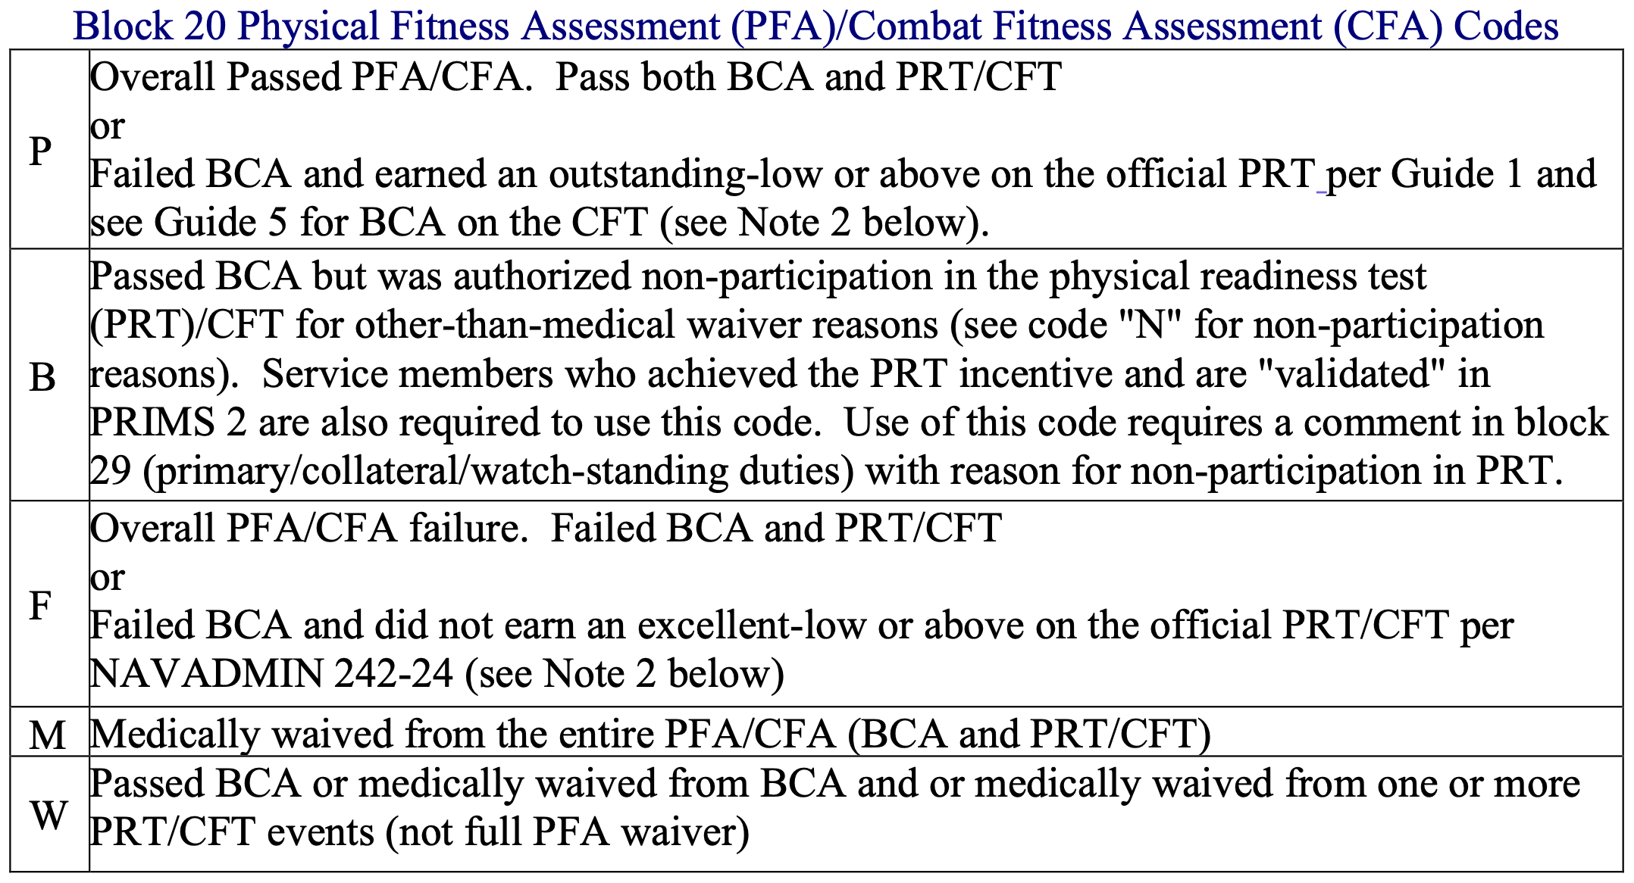
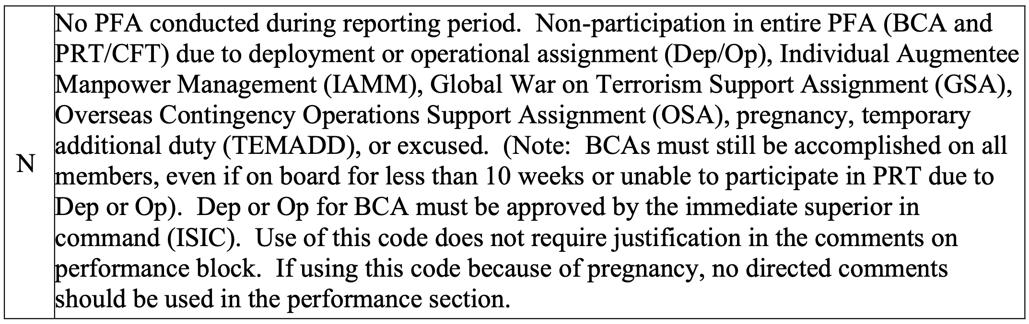

Ensure that data entered here matches data in the official Navy Physical Readiness Information Management System 2 (PRIMS 2) for the cycles being referenced. Do not use physical readiness tests (PRTs) and body composition assessments (BCAs) that are not part of an official PFA.

Document all official PFAs in block 20 using the following format: PPP. This example indicates the individual passed three official PFAs during the reporting period. Do not enter spaces or slashes between the characters.
Enter specific PFA cycle identification information in block 29.

The format for block 20 must be from the oldest to most recent PFA performed during the reporting period (e.g., PBF in block 20 and “PFA: 17-2/18-1/18-2” in block 29 indicates that the member passed 2017 cycle two, did not participate in the PRT portion of 2018 cycle one, and failed 2018 cycle 2.

Performance trait grades and recommendations must conform to the following:

- No mandated or prohibited trait mark is required in *Military Bearing/Professionalism* for promotability and/or retention for the reporting period in which member's first or second PFA failure occurs. COs will evaluate the Sailor's PFA progress or lack of progress when evaluating performance.
- For a reporting period in which a member has accumulated three PFA failures in a four year period:
  - Officers are mandated to receive minimal marks or trait grades in Military Bearing (FITREP block 35) or marked for Significant Problems (FITREP block 42). COs are encouraged to document member's progress and initiative in attaining current physical fitness standards and suitability for retention in comments section (FITREP block 41).

Block 21 – Billet Subcategory (If Any)

Welcome to what is probably the most confusing block on a FITREP. Do not leave this block blank.

If you are an intern, put “INTERN”.

If you are a resident, put “RESIDENT”.

If you have released resignation or retirement orders (meaning you can get a copy of the orders on NSIPS), put “APPROVED”.

If you have been deployed in the last year or are currently deployed, look at the table below to see if you meet the criteria to enter “INDIV AUG”. (This website can help calculate the duration in days between two dates.)

If you are an OIC or CO, you may have to use one of the codes detailed in the table below (OIC, CO AFLOAT, CO ASHORE).

If you don’t fit any of these categories, you are likely going to be correct if you put “BASIC”.

If none of this seems to fit or you are just plain confused, put “NA” and let your leadership decide what category you should be.
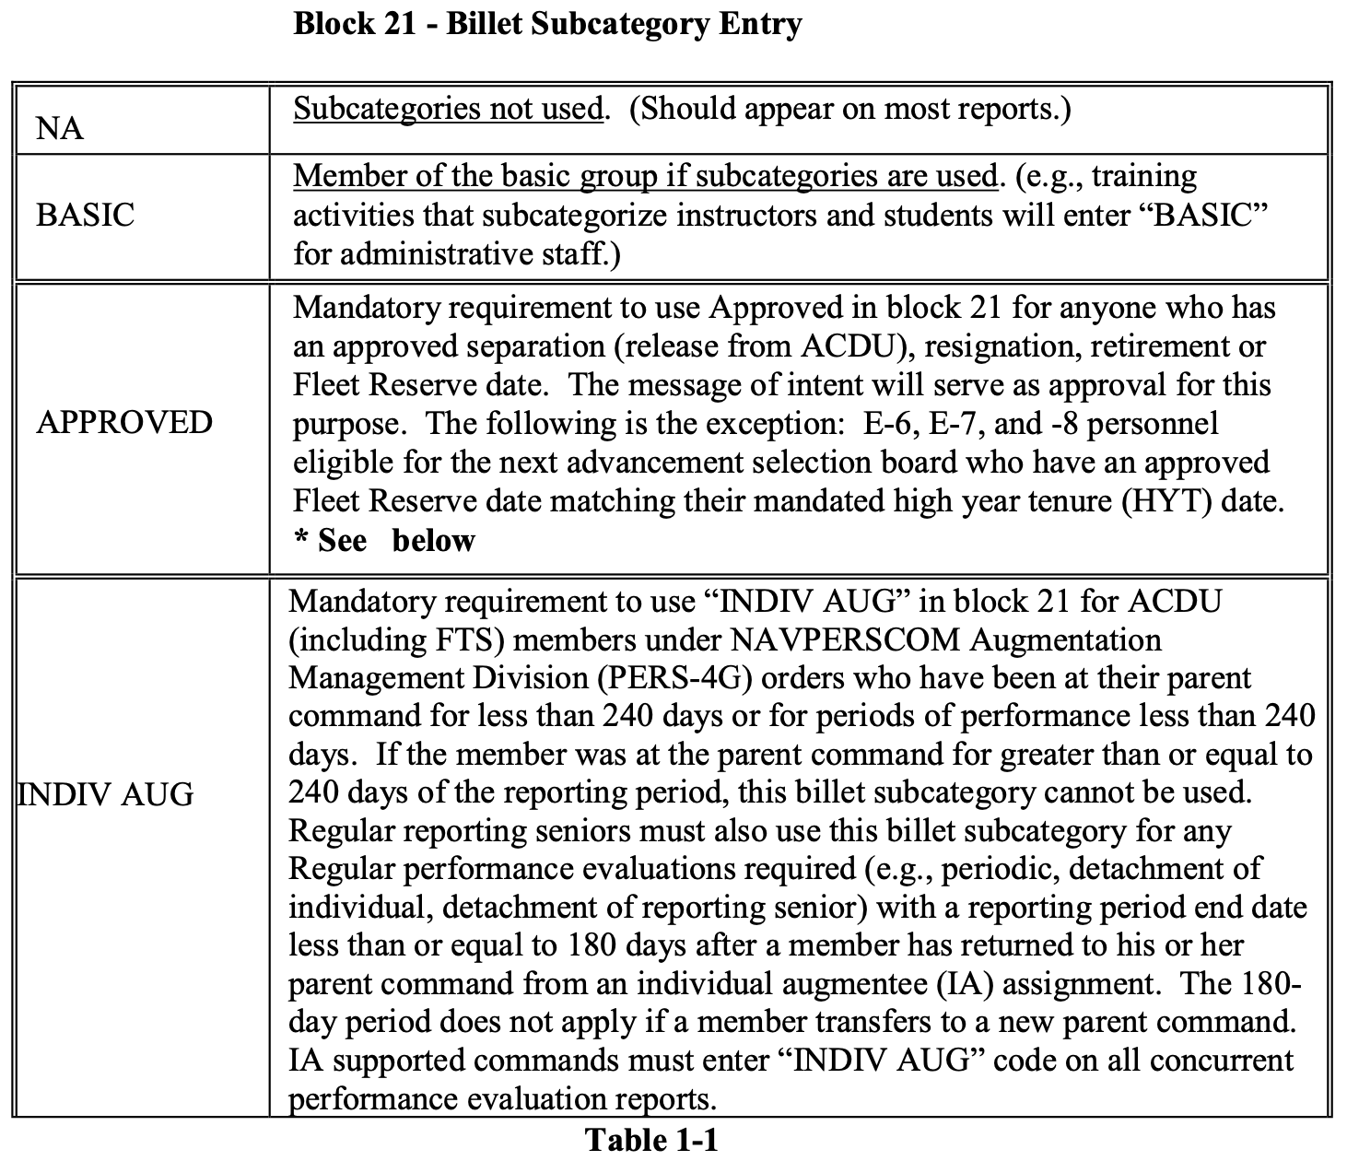
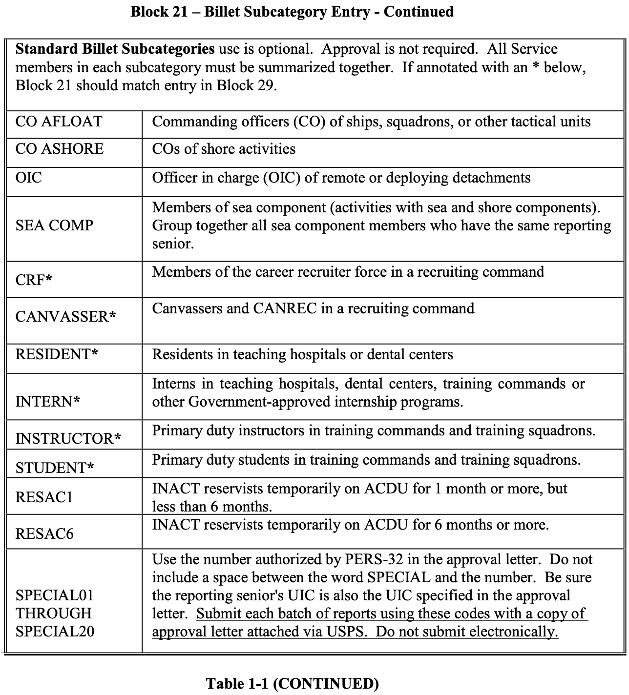

Block 22 – Reporting Senior

Enter the last name, initials, and suffix, if any, of your reporting senior. Place a comma after the last name. For example, you would type “STJOHN, O F”.

Block 23 – Grade

Enter the reporting senior's grade. The entry must be five characters or less. Do not use hyphens. Do not leave this block blank.
Navy and other Sea Service officers use the following:

- ADM
- VADM
- RADM
- RDML
- CAPT
- CDR
- LCDR
- LT

Army (USA), Air Force (USAF), or Marine Corps (USMC) officers use:

- GEN
- LGEN
- MGEN
- BGEN
- COL
- LTC
- MAJ
- CPT

Civilian reporting seniors use the U.S. Federal Government civilian grade (e.g., GS15, SES4). If the reporting senior does not have a grade designation, enter “CIV”.

Note: Reservists who submit reports as civilians must use their civilian, not military grade.

Block 24 – Desig

Enter the reporting senior's four-digit officer designator. There are a few exceptions. If the reporting senior is a member of another service, enter the abbreviation for that branch of service (e.g., USAF, USA, USMC, USCG, USPH, NOAA). If the reporting senior is civilian, leave it blank.

Block 25 – Title

Enter your reporting senior’s title (abbreviated if necessary). The entry may be up to 14 characters and spaces. Always use “CO” for Commanding Officer and “OIC” for Officer-in-Charge. For other titles, use the complete title or a common abbreviation. Examples include:

- COMMANDER
- XO
- DEPT HEAD

For delegated reporting seniors, indicate the level of delegation rather than function (e.g., XO vice ACTING CO, DEPT HEAD rather than SUPPLY OFFICER). DIRECTOR, standing alone, may be used only as a command title. Delegated reporting seniors use DEPT DIRECTOR, DIV DIRECTOR, etc., to indicate the level of delegation.)

Block 26 – UIC

Enter the UIC of your reporting senior's command. Note that the reporting senior’s UIC may be different from your UIC in block 6. For example, when you are in training you often have a different UIC in block 6 than what will be listed in block 26.

Block 27 – SSN/DoD ID

The full SSN with hyphens after the third and fifth digits should be used for all reports that will be mailed (e.g., 000-00-0000).

Block 28 – Command Employment and Command Achievements

This is where you put a brief statement of command employment and significant command awards or achievements during the period of the report. Your command should provide the text for this block, or you can get it from an old FITREP (realizing that these statements do occasionally get updated).

Blocks 29-32

Block 29 - Primary/Collateral/Watchstanding Duties/PFA

The small box in the upper left of block 29 is an important box! What you put in there should be your most important leadership job and is displayed on your PSR at the promotion board. Here you can see an example from block 29 on one of my FITREPs when I was the Senior Medical Officer (SMO) in the Emergency Department at NMC Portsmouth and how it displays on my PSR:

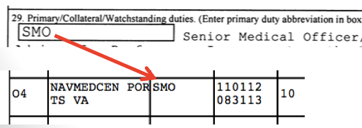

In this box enter an abbreviation of 14 or fewer characters and spaces for the most significant duty for the period reported on. Refer to block 21 because sometimes what you put in this box should exactly match what is in block 21 (RESIDENT, INTERN, OIC, etc.).
The remainder of block 29 consists of one to four elements, as follows:

- Duty Titles: Beginning to the right of the abbreviation box, enter duty titles and the number of months each duty was assigned during this reporting period. Enter duty titles in the following order: most significant primary duty (corresponds to the abbreviation in the block 29 primary duty box), other primary duties, collateral duties, and then watchstanding duties. For example, “DEPARTMENT HEAD, PEDIATRICS-7; GENERAL PEDIATRICIAN-7; CHAIR, CREDENTIALS COMMITTEE-3; ON CALL WARD PEDIATRICIAN-7.”
- Job Scope Statement: Briefly state the scope of your primary duty responsibilities. Include such items as technical or professional duties, the number of personnel supervised, and the size of any budget administered. Job scope statements are optional for operational billets. Example: “Academic Chair of a department of over 100 military and civilian personnel providing comprehensive primary and pediatric specialty care with an annual budget of approximately $600,000.”
- Periods Not Available for Duty: Identify any periods during which you had no duties assigned. Such periods may include en route time prior to reporting, TAD, unusually long leave, deployments, etc. If it is necessary to include maternity leave, identify it only as "Leave." Example: “TAD: 26OCT18-26NOV30; LEAVE/TRANSIT: 26JUN18-26JUL30.”
- PFA: Annotate the PFA cycle results as reflected in PRIMS: cycle, overall pass/fail, BCA within standards/not within standards, numbered PRT score, and overall PRT score category. Example: For a FY26 cycle 1 PFA: passed overall PFA, within BCA standards, scored a 95 on the PRT, and an overall score category of outstanding high will reflect “26-1: P/WS/95/OH”

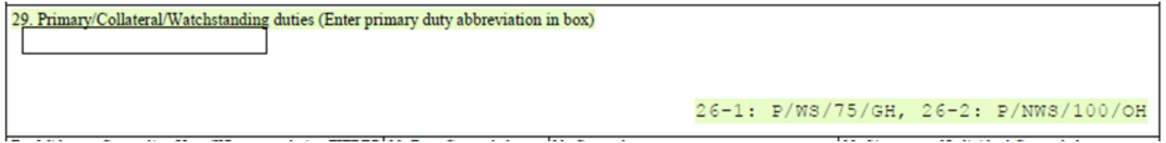

- If one of the letters in block 20 is “B,” make sure that somewhere in this block you enter the reason for non-participation in the official PRT.
- In summary, when added all together, the entire block 29 would look like this:

“DEPARTMENT HEAD, PEDIATRICS-7; GENERAL PEDIATRICIAN-7; CHAIR, CREDENTIALS COMMITTEE-3; ON CALL WARD PEDIATRICIAN-7. Academic Chair of a department of over 100 military and civilian personnel providing comprehensive primary and pediatric specialty care with an annual budget of approximately $600,000. TAD: 26OCT18-26NOV30; LEAVE/TRANSIT: 26JUN18-26JUL30. 26-1: P/WS/95/OH.”

Block 30 – Date Counseled

If mid-term counseling was received during the reporting period, enter the date you were counseled. The date may be selected from the drop-down calendar or recorded in YYMMMDD format (e.g., 14FEB20).

If counseling was not performed because the counseling date did not fall within the reporting period, enter "NOT REQ" in block 30.

If counseling was not performed for any other reason, enter “NOT PERF”, and provide a brief explanation in block 31.

Block 31 – Counselor

Enter the last name, initials, and suffix, if any, of whoever did your mid-term counseling. Place a comma after the last name. For example, “STJOHN, O F”.

If the entry in block 30 is “NOT PERF,” enter a brief explanation in block 31 (for example, “TAD” or “ILLNESS”). If a longer explanation is needed, enter “SEE COMMENT” and provide an explanation in block 41.

Block 32 – Signature of Individual Counseled

To reduce the number of signatures required and possible rejection issues, there is no requirement to sign block 32. It should be left blank. An individual who believes that the counseling they received was inadequate may submit a statement to the record.

Blocks 33-39 – Performance Traits

Before you start working on these blocks, try and find out what your reporting senior’s cumulative average (RSCA) is for your rank. One of the most important markers of a good FITREP is that your trait average is above the RSCA. Here are a few ways to find out what it is.

First, to have a trait average, your reporting senior must have served as the reporting senior for officers of your same rank from any Corps. If they have not done this, they’ll have no pre-existing average. For example, if you are a LCDR, your reporting senior does not have to have ranked Medical Corps LCDRs. If he/she has ever ranked a LCDR of any kind (Nurse Corps, Medical Service Corps, etc.), then they will have an average.

If they have an average, here are the ways to find it:

- If you’ve already received a FITREP from them in your current rank, then you can look at your PSR, which you download from BUPERS On-Line. The number in the lower right in the “AVERAGES” column (explained in blue text below) is their average for that rank.

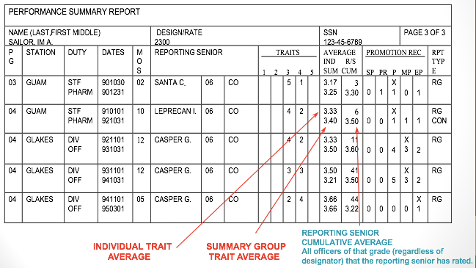

- If you haven’t received a FITREP from them, maybe you have a friend in the same rank who has received a recent FITREP from them. You can look at their PSR if they’ll let you.
- You can ask your chain of command or command FITREP coordinator. They often know because they are trying to make sure that all the FITREPs being done don’t change the RSCA in ways he/she doesn’t want.
- You can ask the reporting senior. They just may tell you.

The bottom line is that when you are drafting your FITREP, you want to try and find out the RSCA and grade yourself above it. In the end, the ranking process may move you below it, but by submitting the draft with an above average grade you may increase the chances you stay above it.

Once you obtain the RSCA (or if you can’t), for each trait in blocks 33-39 you must place an “X” in one box. Each block will be explained individually below.

Block 33 – Professional Expertise

For Medical Corps, in general you get a 4.0 if you are board-eligible and 5.0 if you are board-certified. If that doesn’t apply to you because you are still in training or a different Corps, what you get will be determined by your reporting senior’s preferences.

Block 34-37

Use these blocks to balance your score and give yourself the overall trait average you are looking for. Do not give yourself less than a 3.0 in any of these blocks.

Block 38 – Leadership

At promotion boards, the Navy is looking for leaders, so if there is any block you should give yourself a 5.0 this is it!

Block 39 – Tactical Performance

Mark this block NOB, unless you are an active Navy SEAL.

The Final Review of Blocks 33-39

Make sure you do not decrease in any of these blocks when compared to your last FITREP unless:

- You were selected for promotion.
- You were promoted.
- Your competitive group changed (like going from being a resident to a staff physician).
- Your reporting senior or command changed.

You should still try to avoid a decrease in any of these blocks, but if the above situations are applicable to you a decrease may be unavoidable and is generally acceptable.

Expect that your chain of command will alter whatever you give yourself, so my advice is to round up for any blocks you are unsure of.

Block 40 – Career Recommendations

Enter one or two career recommendations that are consistent with your rank and desired career path. The first recommendation should be for your next significant career milestone and useful to detailers and screening boards. A second recommendation is not required if you only want one listed.

Each entry may have a maximum of 20 characters and spaces. If necessary, use two lines for the entry. Do not leave this blank as promotion boards will look at what is in this block. If for some reason you do not desire an entry in this block, enter “NA” or “NONE” in the first block. Do not enter very long-range goals (e.g., do not recommend yourself for XO when you are a LT).

These are the reporting senior's recommendations, based on performance. They are not binding on detailers and do not preclude consideration for other opportunities.

Block 41 – Comments on Performance

You block 41 narrative is where you express why you should be rated highly on your FITREP and promoted at the promotion board. Some tips on style include:

- Be concise as space is very limited.
- Because space is limited, don’t repeat what you already said in block 29. Promotion board members will read block 29.
- Bullet style is preferred, as detailed below.
- You don’t have to mention your name. They know this block is about you. It is on your FITREP! For example:
  - NO – “CAPT Schofer is a stellar officer who…
  - YES – “A stellar officer who…”
- Always write in the past tense.
- If one of the letters in block 20 is “N” and it is due to the service member being pregnant, per paragraph 2.f. of NAVADMIN 272/21:
  - If using the “N” code because of pregnancy, no directed comment should be used in the performance comment section.
  - Do not quote from medical reports or summaries and do not include comments pertaining to medical issues (physical and/or psychological, e.g. pregnancy, post-partum, etc.) that do not affect the members performance of duties and/or his or her effectiveness as a leader.
- Do not use abbreviations or acronyms without explaining them. Promotion boards may have a line officer on them, and he/she needs to understand what you are doing so they can brief your record. They won’t know what a STEMI, CVA, and other medical abbreviations mean.
- Quantify wherever possible to give credibility to the statements.
- Make sure you don’t repeat bullets from your last FITREP. Your narratives need to read like a book that describes a growing leader, not someone who is recycling the same stuff over again.
- If you are looking for language to use in your narrative, get the convening order for the most recent promotion board for your next rank. In it you’ll find all the qualities and skills they are looking for when deciding who to promote. You can find them on this webpage. You just click on the promotion board you are looking for, and you’ll find a link to the board convening order. Remember, you must go to the last board to have been completed, which may be the year prior. You can also just use this blog post to pull out some language from various promotion board documents.

This is the most common format for block 41:

MY #X CDR AMONG 5 CDRS AND A RISING NAVAL LEADER!
(one line of white space)
-Bullet
-Bullet
-Bullet
-Bullet
-Bullet
(one line of white space)
MY STRONGEST RECOMMENDATION FOR PROMOTION TO CAPTAIN!

Here is what you should not do:

My #X CDR among 5 CDRs and a rising Naval leader! Bullet. Bullet. Bullet. Bullet. Bullet. My strongest recommendation for promotion to Captain!

Run-ons like this are too hard for board members to read.

Writing the Opening Line of Your FITREP

Your opening line should get someone’s attention and paint the picture of a developing leader ready to promote to the next rank. The following are good examples, but you may have to put something generic as some of these specific examples will be written by your command after all the FITREPs are ranked. In other words, you can’t say you're the #2 of 5 CDRs until all the FITREPs have been tiered and ranked. If you are writing for an operational commander who doesn’t know a lot about Navy FITREPs, you may be able to rank yourself.

Getting what is called a soft breakout - especially if you are getting a 1 of 1 FITREP (you are not getting ranked against anyone) – is optimal. A soft breakout is where you get ranked against all corps/designators or across services by the reporting senior. Here are some examples:

- MY NUMBER #1 LCDR OUT OF 25 ACROSS ALL DESIGNATORS.
- #3 OF 15 LCDRS REGARDLESS OF DESIGNATOR.
- IN THE TOP 10% OF OVER 200 LCDRS I’VE RATED ACROSS ALL DESIGNATORS.
- #1 OF 17 HAND-PICKED OFFICERS ON MY STAFF.
- FUTURE EXECUTIVE MEDICINE LEADER. #2 OF 5 CDRS ON MY STAFF.

Forced distribution statements can also be good. They are when the reporting senior explains why they couldn’t rank you higher despite your excellent performance. Here are some examples:

- MY #1 MP, WOULD HAVE BEEN EP BUT RANKED AGAINST HIGHLY COMPETITIVE SENIOR OFFICERS.
- WOULD HAVE BEEN AN EP BUT RANKED AGAINST THE DIRECTOR FOR MEDICAL SERVICES.
- IF NOT FOR FORCED DISTRIBUTION…

If none of these situations apply, then just write the best opening line you can about yourself. Here are some from my last few FITREPs:

- EXEMPLARY PERFORMANCE AS COMMANDING OFFICER OF A JOINT UNIT!
- EXEMPLARY LEADER AND ACADEMICIAN WHO PERFORMED AT THE LEVEL OF A SENIOR COMMANDER.
- NAVY MEDICINE RISING STAR WITH EXPANDING LEADERSHIP AND ACADEMIC EXCELLENCE!
- NATIONAL LEADER AND SUPERSTAR IN EMERGENCY MEDICINE WITH UNPARALLELED ACADEMIC PRODUCTION!
- TOP-TIER, FIRST-RATE CLINICIAN WHO IS A NATIONAL LEADER IN EMERGENCY MEDICINE.

You get the idea…

Writing Your Bullets

Here are some tips for writing FITREP bullets:

- As mentioned above, always write in the past tense.
- Also, as mentioned above, you can borrow language from promotion board documents.
- Clinicians – focus on how you contributed to MTF optimization, increased enrollment, improved access to care, improved customer satisfaction, etc.
- Researchers – focus on the impact of your work on DoD and the Navy, not the science.
- Get Real Get Better (GRGB) comments are now required for Commander and Captains and encouraged for all.
  - To meet this requirement, I would make at least one bullet that focuses on an initiative where you “embraced the red” and what you did to correct it.
- Put your leadership in your profession into context that the promotion board will understand, including the line officer on the board.
- Tell how you contribute to your command, the Navy, and the DoD. Mention command/Navy/DoD-wide impact you made and collateral duties.
- Discuss mentorship and how you impact others.
- Make sure your bullets show growth and increased responsibility. As mentioned above, don’t recycle FITREP bullets from previous FITREPs.
- Mention awards, like Medical Officer of the Quarter, awards from previous commands that were not on your last FITREP, etc.

Here are some example bullets:

- Achieved diplomate status in the American College of Healthcare Executives. Increased preparation for Executive Medicine positions.
- Certified by American Board of XXXXXX. Only 10% of Navy _____ have earned this elite designation.
- Increased clinic visits by over 200 per quarter and decreased referrals to the network by X%.
- Developed XXXXXX clinical pathway and saved $X dollars annually.
- Attended training in XXXXX and enhanced her already strong skills in XXXXX.
- A member of the XXXX committee and achieved…
- Created a 70% cost savings totaling $750K/year compared to outsourcing.

Block 41 Closing Statement

Always end with a recommendation for the next promotion and assignment/position. If you are in-zone for O6, you should try to include an Executive Medicine recommendation if you are interested in that line of work. Your reporting senior may have a standard way he/she likes to do the last line. For example, EPs get the “strongest recommendation” for promotion, MPs get a “strong recommendation”, and Ps get a “recommendation” for promotion.

Here are some examples from my FITREPs:

- FLAG OFFICER POTENTIAL!!! MY HIGHEST RECOMMENDATION FOR EARLY PROMOTION!!!
- SHOULD BE PROMOTED EARLY TO FILL SENIOR LEADERSHIP POSITIONS IN NAVY MEDICINE!
- DESTINED FOR EXECUTIVE MEDICINE. MY STRONGEST RECOMMENDATION FOR PROMOTION TO CAPTAIN!
- A FUTURE SENIOR LEADER IN NAVY/EXECUTIVE MEDICINE. RECOMMENDED FOR PROMOTION!
- A DYNAMIC NAVY LEADER WITH POTENTIAL FOR EXECUTIVE MEDICINE. PROMOTE AHEAD OF PEERS!
- A FUTURE SENIOR LEADER OF NAVY MEDICINE. AN EASY CHOICE FOR ASSIGNMENTS LEADING TO XO/CO/EXECUTIVE MEDICINE. PROMOTE TO CDR NOW!

Block 41 – Final Thoughts

If you are detaching from your command, try to identify your next assignment in block 41. This will assist those looking at your FITREP during a promotion board.

If you are in Full-Time Outservice Training (FTOS), make sure you have your program/fellowship director create a narrative to cut/paste into your NOB FITREP as block 41. It is hard enough to promote while in graduate medical education (GME), so make sure you fill block 41 and give yourself all the help you can get.

Block 42 – Individual Promotion Recommendation

Place an “X” in the box for the promotion recommendation you think you deserve. In general, you will be marked NOB if you have been at the command less than 90 days, although the specific policy is up to the reporting senior. If you are an ENS or LTJG, you are prohibited from receiving a promotion recommendation higher than a P or Promotable.

Your promotion recommendation may get changed by your chain of command, but if I was you, I’d give yourself at least one higher grade than you think you deserve! Give yourself an EP if you are the only officer getting a FITREP in your competitive category. Make sure you do not downgrade yourself from your last FITREP and try to make sure you “break out to the right” and don’t “move to the left” on your PSR.

This is what “breaking out to the right” or moving from a P to an MP and then an EP looks like on your Performance Summary Report (PSR) that is shown at promotion boards:

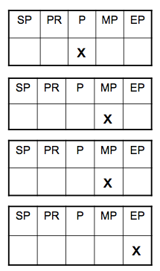

This is what “moving to the left” looks like, which you want to avoid unless it is explainable:

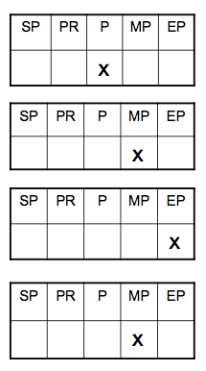

The most common reasons this would happen to you that are expected by promotion boards and generally acceptable are:

- You are selected for promotion or promote to the next rank.
- You change competitive categories, like when you graduate from residency, stay at your training institution, and are now competing with staff physicians on your FITREP.
- You move to a new command or get a new reporting senior.

Block 43 – Summary

This will be calculated automatically once all the FITREPs are done.

Block 44 – Reporting Senior Address

Usually, you will get this info from your last FITREP, someone else’s last FITREP, or your chain of command.

Enter the reporting senior’s address and phone number. If they have orders, the info should be for their next command. If they have retirement orders, the address should be their retirement address. It is optional for a reporting senior to provide the member a copy that contains their retirement address, but the version submitted to PERS must contain it.

Block 45 – Signature of Reporting Senior

Your trait average will be here, but you won’t know the summary group average (and whether you are above or below it) until all the FITREPs in your competitive group are done. If you are getting a 1/1 FITREP, then this average will be the same as your trait average.

Block 46 – Signature of Individual Evaluated

This block is filled out when your FITREP is returned to you for review before you sign it. Verify your name, social security number/DoD ID number, and other administrative entries are correct.

My strong advice is that if you have questions about your FITREP, discuss those with your chain of command before you sign it. According to the FITREP instruction, the command is supposed to verbally discuss your performance during the period of the report and explain any adverse matters.

Once you have decided to sign the FITREP, check the box indicating your intention to submit or not to submit a statement (see below for the discussion on statements), and sign and date all copies electronically or with black or blue-black ink. Your signature does not imply agreement with the report but merely certifies you have seen the report and understand your right to submit a statement.

The Final Check

Before you finalize your FITREP, do one final check to make sure you have not made any of the top 5 critical FITREP mistakes:

- Getting anything other than an EP when you are getting a 1/1 FITREP, also known as an “air bubble.”
- Both officers in a competitive group of 2 getting a MP FITREP.
- Declining from an EP to an MP without changing competitive groups (or “moving to the left”).
- Not getting a 5.0 in Leadership.
- Giving yourself an overall trait average less than your reporting senior’s average.

This blog post explains each of these in detail.

Submitting a Statement

You may submit a statement on any FITREP, independent of whether the reporting senior considers it adverse. I have never seen any good or tangible benefit come from submitting a statement but to each his own.

The statement must:

- Be submitted within two years after the report ending date or provide acceptable justification for the delay.
- Be no more than two pages.
- Not have enclosures.
- Be temperate in tone and confined to pertinent facts.
- Not include accusations or countercharges.
- Not question or impugn the motives of the reporting senior or other individuals.
- Not contain a request to modify, remove, replace, or investigate a report. Such requests may be made only as part of one of the appeal processes that exist.

If you want to submit a statement, you should refer to chapter 17 of the FITREP instruction, BUPERSINST 1610.10G.

The reporting senior will write a one-page endorsement that will be filed with the FITREP and your statement, and you’ll get a copy.

Block 47 – Regular Reporting Senior Signature on Concurrent Report

If you are getting a concurrent FITREP, like when you are deployed, your regular reporting senior will sign here. (If you are getting a concurrent report, read this post for tips to improve your FITREP.)

PART 3 – ACTIVELY MANAGE YOUR CAREER

The Navy may seem like an overwhelming bureaucracy, but it is run by people. Aside from keeping your record accurate and optimizing your FITREPs, interacting with some key people at various career points can be critical. The most important people would include your:

- Specialty Leader
- Detailer
- Corps Chief’s office
- Flag Officers

Let’s talk about them one at a time.

Specialty Leader vs Detailer – What’s the Difference?

Many officers don’t understand the difference between their Specialty Leader and their Detailer. Let’s clarify a few differences between the two.

The first difference is who they work for. A Specialty Leader works for Navy Medicine (BUMED), the Surgeon General, and the Corps Chief. A Detailer works for Navy Personnel Command (NPC). NPC is a line command, while BUMED is obviously medical. This difference is probably not of significance to the average Naval officer, but it can make a difference at times because these two commands (and people) will look at things from a different perspective.

For example, let’s say you are one of two subspecialists at NMC Camp Lejeune and you do not have a full clinical load. You decide you want to leave early to get to your next command, Naval Medical Center Portsmouth (NMCP), because they are down one provider in your specialty due to the illness of another member of your community. Your Specialty Leader will probably endorse this early move because it makes sense. You are underemployed at Lejeune and there is a need at NMCP.

Your Detailer, however, will look at it differently. First, you haven’t served your full tour, so moving you early will require a waiver that may be denied by PERS. This largely has to do with money and PCS rules and has nothing to do with your specialty or the needs of the Navy. I’m not saying that Detailers don’t care about the needs of the Navy because they do, but they are constrained by the rules of PERS while a Specialty Leader is not.

The second difference is what they do. A Specialty Leader serves as a liaison between you, BUMED, and your specialty. He or she also coordinates deployments, although the control they have over this was lessened by the return to platform-based deployments (deployments determined by what billet you are in or what unit/platform you are assigned to rather than whose turn it is to deploy). They also serve as a consultant both to you and your Detailer when it comes to career management and PCS moves.

A Detailer is your advocate to help you advance in your career, prepare for promotion boards by improving your officer service record, and negotiate orders for your next PCS. They will often speak with both you and your Specialty Leader while trying to balance your needs with the needs of the Navy. They also are the final approval authority for extension requests, write your PCS orders, and collect names of officers interested in being on promotion boards.

The third difference lies in what they don’t do. Specialty Leaders do not write orders. Many physicians think that the Specialty Leader is the one who decides what orders they get and where they PCS, but the reality is that Specialty Leaders can’t write orders. Only Detailers can, therefore it is the Detailer who makes the final decision in nearly all cases. If there is a good Specialty Leader-Detailer relationship, most of the time both agree and there is no controversy, but about 5% of the time there is at least some level of disagreement that must be worked out.

Detailers can write your orders to a command, but they do not influence who gets command-level leadership positions. For example, you may want to go to Jacksonville to be the Department Head of your specialty’s department. A Detailer can write you orders to Jacksonville, but who the command picks to be Department Head is up to them, not the Detailer (or the Specialty Leader).

Specialty Leaders will often talk to commands, but Detailers usually do not. The Detailer is SUPPOSED to talk to three people – you, the Specialty Leaders, and the Placement Officers. The Placement Officers are officers at PERS who represent the commands. You can think of them as the detailers for commands. They make sure that commands aren’t taking gapped billets, that the officers sent to the command meet the requirements of the billets they are entering, and weigh in on other issues like extension requests.

I say that a Detailer is SUPPOSED to talk to three people and USUALLY does not talk to commands, but the reality is that commands frequently call the Detailer instead of talking to their Placement Officers. This often happens because someone at a command knows the Detailer but doesn’t know the Placement Officer. In addition, the Detailer is usually a physician (three Medical Corps Detailers are physicians, the fourth is a MSC officer) and the Placement Officer is always a MSC officer. Physicians like talking to other physicians.

Finally, Specialty Leaders do not alter your officer service record. In fact, unless you send it to them, they can’t even see it or your FITREPs. Detailers, on the other hand, can see just about everything and can update/change some things, mostly additional qualification designators or AQDs.

Detailer

As discussed somewhat above, your Detailer should be your primary contact for issues related to orders. I would recommend you contact them 9-18 months ahead of your projected rotation date (PRD) to discuss options available to you. These will normally include extending or retouring (taking a new set of orders) at your current command, taking orders to a new command, resigning, retiring, and any relevant family or medical conditions that affect your assignment. Here is a link to an entire blog post about managing your PRD.

They will also periodically send out information on what I call alternative billets or opportunities. The most common example is something called the non-specialty specific billet opportunities. This is usually sent out over the summer and advertises billets that do not require a specific specialty and are projected to be available in the next year. Most of these billets are career enhancing and will lead to promotion if you do well in them. There are also educational opportunities in there like War College.

They can also help you review your record, prepare it for promotion boards, and try to get you on a promotion board.

Specialty Leader

Your Specialty Leader should also be a contact when discussing extensions, retours, or any future orders, but realize that it is the Detailer that makes the final call. Don't short yourself by ignoring the Detailer. The Specialty Leader also influences deployments and temporary additional duty (TAD) requests, although they do this less now than in the past, as discussed above.

The Specialty Leader will be the person scoring, selecting, and defending any graduate medical education (GME) applications you submit, so make sure you discuss any GME related desires with them. They need to know what you want and why.

Finally, much of the communication in Navy Medicine will be disseminated through Specialty Leaders, so make sure they have your most up-to-date contact information. If you are not getting regular communication from them, I would ask why.

Corps Chief’s Office

Excluding the admiral who is your Corps Chief, your Corps Chief’s Office is composed of the Deputy Corps Chief, Career Planner, Policy & Practice Officer, and Reserve Affairs Officer (RAO). All will probably be a Commander or Captain, and the RAO will be a Reservist. The titles are self-explanatory and denote their usual role in the office.

When it comes to managing your career, the Corps Chief’s Office will be your point of contact for a few critical things. Most commonly, they send out opportunities for career building activities like training and leadership positions. You will want to make sure that you get any updates they send, which are often disseminated through your Specialty Leader. In addition, they run the Milestone, Executive Medicine, and Senior Executive Medicine screening and slating process.

Executive Medicine positions are Executive Officer (XO) and Commanding Officer (CO) positions, and the Senior Executive Medicine process is largely for officers who have already served as an XO/CO or are applying for very senior operational positions. Certain positions have been labelled Milestone positions. They require you to apply, have your record screened at a board run just like a promotion board, and then you compete among the other Corps and officers to get “slated” or assigned to a Milestone position. In most cases, you need have been selected for O5, although you can apply for a Milestone as an O4 if your Corps Chief approves.

Every year in the spring BUMED puts out application instructions, so if you are interested be on the lookout for them. What is the easiest way to promote to O6? Applying for a Milestone, getting slated, and doing well may be the most successful path in Navy Medicine.

Your Corps Chief’s Office will be a major source of career building information and opportunities. Often this information will be disseminated by your Specialty Leader. Do everything you can to make sure you get this communication. In addition, I do what I can to make sure all opportunities I find out about are put on MCCareer.org. My information is likely biased to the Medical Corps, though, since that is my Corps.

Flag Officers

At the beginning of my active-duty career in 2001, I think there were between 15-20 admirals or flag officers in Navy Medicine. As of now, we have much less than that. As a result, admirals have less of an influence on your career, but they can still play a major role in your future. Every time you interact with one, it has the potential to impact your career. The same can be said about interactions with their staff. Having been on multiple flag staffs, I can attest that what you say to a flag staff will affect that flag officer’s opinion on you and your future.

How should you interact with flag officers? First, I’d say you should always respect their rank. You can never go wrong by adhering to traditional military customs and courtesies. I don’t care if you were both the same rank once and you called them by their first name. Those days are over. They are an admiral now, and you should treat them as such, especially in public.

Second, because there are so few of them now, your interactions will be fewer. When they do occur, though, the interaction has the potential to be more impactful. Recognize that and be prepared for the interaction if you knew ahead of time that it was going to occur. Give some thought to the issue(s) or question(s) you plan on discussing.

Who’s On Your List?

I wrote the blog post below in 2015 when I was a CDR. I then re-posted it in 2019 with some italicized reflections/comments after 4 years of career progression. I still think it rings true today:

In my opinion, every Naval physician needs to have a list of people. On this list are the people who you absolutely, positively will not mess with. When you talk to them, you show them the utmost respect. When they ask you for something, you give it to them better and faster than you ever give anyone anything. These are the people who have determined your career path to this point and are likely to continue to steer it for the near future.
Who’s on your list? If you don’t know, you should think about this as soon as you can. You might think it is silly, but I’d make a list. Just to show you I’m serious, I’ll share my list (as it was when originally posted on the blog):
- Current Emergency Medicine (EM) Specialty Leader
- Prior Deputy Commander of NMC Portsmouth
- Prior EM Specialty Leader
- Current Director of Medical Services at NMC San Diego
- Prior EM Specialty Leader and Deputy Medical Corps Chief
Why are they on my list? They are Emergency Physicians like me, and they are the most senior and potentially influential people in my career. They are the people who are senior to me, well thought of in my specialty, and get phone calls or in person inquiries when I apply for a leadership position. For example, one of the people on this list thought of me when the Detailer job became available and endorsed me for it. (That same person just made me the incoming Deputy Medical Corps Chief. I show up at BUMED on September 3rd.)
Who’s not on my list? There are no admirals on my list (at least there weren’t at the time – there certainly are now). As a CDR, it is rare that I’m on the radar of an admiral. Some of them know who I am, and some of them could have a major impact on my career path, but it is unlikely that they’ll take a huge interest in my career until I’m a CAPT and qualify for major leadership positions working directly for them (somewhat of a prescient post, I guess). If an admiral wants to know about Joel Schofer, they’ll probably call one of the CAPTs on my list and ask them about me.
Who should be on your list? The people you should consider putting on your list include:
- Your Specialty Leader and prior Specialty Leader
- Your Detailer
- Influential people in your specialty who are 1-2 ranks senior to you
- Whoever is currently in the job(s) you want
Undoubtedly there are other people you should consider, but this list is a good start.
Once you create the list, here are the things you need to keep in mind. Always treat these people with the utmost of respect. You should always treat everyone with respect, but these people get special attention. Never get into an argument with them. I’m not saying you must be a “yes man” (or woman) and agree with everything that they say, but any disagreement needs to be collegial and respectful. You want to prevent them from getting mad at you, if possible. When they ask you for something or they give you a task, it immediately rises to the top of your to-do list. In addition, you never give them anything but your best, maximal effort.
The Navy is a large organization that can appear impersonal, but people run it. The people on your list are the ones who are going to determine your future and whether you get want you want or not. If I were you, this is one list I’d put some thought into and make.

Managing Your Career Once You Promote

If you are one of the lucky people to be selected for promotion, here are some things for you to consider.

The next 2-3 years of FITREPs may mean very little to your overall career. First, you are soon going to be one of the newest officers in a new competitive group. If you are at a medium to large command with a decent sized competitive group, no matter what you do when you are junior, you are likely to get a P (promotable) on your FITREPs. That is just how it works for many larger commands.

This means that this is the perfect time to do something “alternative” (off the usual career path) or take a position that you know will get you 1/1 FITREPs or be part of a very small competitive group. Go to the War College. Take an operational job where you’ll get a 1/1 FITREP. Become a Detailer. Apply for fellowship or additional training because if you get NOB FITREPs they won’t hurt you as much when you are junior. Now is the time to do these types of things. You don’t want to wait until you are a few years below zone for promotion. At that later stage, you need strong EP FITREPs.

After you are selected for your next rank is also a great time to move or execute a permanent change of station (PCS). Have you ever been OCONUS? If not, now would be a great time to go. You can PCS somewhere for 2-3 years and then PCS to the command where you are going to set up shop and try to get promoted to your next rank. At OCONUS commands there is more turnover of staff, so major leadership jobs like Department Head and Director positions open more frequently, setting you up to get a leadership position when you return to CONUS.

You may think I’m crazy, but it is time to start thinking about how you are going to make Captain. Getting a job that will make you a Captain is tough and competitive. Now is the time to do the things that will make you an excellent candidate for one of those jobs. Want to be a Residency Director? Maybe you should get a degree in adult or medical education. Want to be a Director? Maybe you should get a management degree like a Master’s in Medical Management or an MBA. Want to be a senior operational leader? Now is the time to do Joint Professional Military Education I or II. Applying for an official Milestone Position is probably the easiest way to make O6 if you get one and are successful.

Here is a list of the jobs that I think will make you a Captain in the Medical Corps. Other Corps will have similar lists you can likely build by getting info from your Corps Chief’s office or Detailer or by closely examining your Corps’ career pathway. Read the list…figure out which of these jobs you are going to use to make Captain…and get busy preparing yourself to get them:
- Residency Director
- Department Head in a large MTF
- Director
- Chief Medical Officer
- Officer-in-Charge
- Major committee chair
- Medical Executive Committee President
- BUMED staff
- Specialty Leader
- Deployment with a senior leadership position
- Detailer
- Senior operational leader
  - Division/Group/Wing Surgeon
  - CATF Surgeon
  - Amphib or CVN Senior Medical Officer

Optimally you’ll have the time when you are an O5 to do multiple jobs on the preceding list. For example, as an O5 I was a Detailer, Specialty Leader, Department Head, Associate Director, and CO of a deployed unit. My next step was to become a Director at a major MTF, and while I was a senior LCDR and CDR I obtained a Naval Postgraduate School MBA as well as achieved certification as a Certified Physician Executive to try and make myself a competitive candidate for a Director position. Ultimately, I became the Director of Healthcare Business at NMC Portsmouth.

Congratulations on being selected for promotion…take a deep breath…and start thinking about some of the things I mentioned above. Before you know it, you’ll be in zone for Captain.

What if You Don’t Promote?

I receive questions all the time about what happens when you are passed over for promotion and are now “above-zone”. If you find yourself in this position, here is what you need to do.

First, realize that it is not the end of the world. Every year many in zone officers are passed over, but several officers from the above zone group are promoted. Even if you do nothing, you will continue to get looked at by promotion boards until you retire, resign, or are forced out of the Navy. There is no limit on the number of chances you get to promote, and your record will be evaluated for promotion every year.

That said, as long as you are still in the Navy you should make active effort to promote. At a minimum, you should consider sending a letter to the promotion board. What do you say in this letter? First, briefly state that you want to be promoted and to continue your career in the Navy. Second, explain what a promotion would allow you to do that you can’t do at your current rank. Answer the question, “Why should they promote you?” For example, if you want to be a Department Head at a large military treatment facility (MTF) or a Residency Director (or whatever you want to do), tell them that you need to be promoted to be competitive for these jobs. The Navy wants to promote leaders. Make it clear to them that you are a motivated future leader.

Try and get letters of support to attach to your letter. These letters should be from the most senior officers who can personally attest to your value to the Navy. In other words, it is probably better to get a letter from an O6 who knows you well than a 3 star who doesn’t. If you are not sure who to ask for letters, ask those more senior to you or your Detailer for advice. Your Specialty Leader is always someone to consider if he/she knows you well and can speak to your contributions to the specialty and Navy.

Have your record reviewed by your Detailer, Specialty Leader, other trusted senior advisor, or by me. Because of promotion board confidentiality, you will never know the reason(s) you did not promote, but most of the time experienced reviewers can come up with an educated guess. They’ll often find things that you were not even aware of, like potentially adverse fitreps, or information missing from your record. Reading this book will help you as well.

Do everything you can to get “early promote” or “EP” fitreps. This is largely accomplished by continually striving for positions of increased leadership. You need to get a job that has historically led to a promotion. For example, if you are a LCDR who got passed over for CDR, try to get one of these jobs and excel at it (this list is not exhaustive and these positions are not the only path to CDR, but they are a good start):
- Medical Executive Committee (MEC) member
- SMO on an amphibious platform
- Regimental Surgeon
- Member of a hospital committee or chair of a smaller committee
- Department Head in a small MTF
- Medical Director/Senior Medical Officer in a medium/large MTF
- Detailer

Meet with your chain-of-command. After you’ve been passed over is not the time to be passive. You need to sit down with your leadership and get an honest assessment from them of how you’re doing and what they would recommend continuing to advance your career. You may not like what you hear, but it is better to find out early if they don’t think you’re doing a good job or that you are unlikely to break out on your FITREPs. That way you can try and put yourself in a better situation by changing commands.

In addition to the above list of things you should do, there are a few things you should not do. Do not lie in your letter to the board. In other words, don’t tell them you want to do Executive Medicine if you don’t really want to. Your record reads like a book, and if it tells a story that is contrary to what your letter says, this is unlikely to help you and may hurt you.

Do not send long correspondence. Promotion boards must read everything sent to them, and a long letter may not be appreciated. Keep it brief and to the point.

Do not ask your current CO to write you a letter to the board if they’ve done an observed FITREP on you. His or her opinion about you should be reflected on that FITREP, so they don’t need to write you a letter. If they’ve never given you an observed FITREP or there is some new information not reflected on prior FITREPs, they could write you a letter. Ultimately it is up to them.

Do not discuss anything adverse unless you want the board to notice and discuss it. This issue comes up frequently and people will ask me for advice, but ultimately it is up to the individual officer. The one thing I can guarantee is that if you send a letter to the board and discuss something adverse, they will notice it because they will read your letter! If you think there is a chance the adverse matter will get overlooked, it is probably better not to mention it and keep your fingers crossed.

Those are my tips for those who find themselves above zone. Most importantly, if you want to promote, NEVER STOP TRYING. You can usually stay in as a LCDR for at least 20 years, and I personally know of people who got promoted their 4th look and have heard of people who succeeded on their 9th try!

Why Should You Care About Any of This?

Because you must actively manage your career to get what you want. This means you should talk with both your Specialty Leader and Detailer 9-18 months ahead of your PRD. You should discuss your short and long-term goals, whether you want to PCS or extend, whether you are planning a Naval career or want to resign or retire, your family situation, and your medical situation if applicable. You should engage with your Corps Chief’s Office, ensuring you are receiving the communication they put out about training and other opportunities and engaging when the time comes that you are considering applying for a Milestone or Executive Medicine billet. You should regularly touch base with anyone else who is “on your list.” You should also prepare for any known interactions with the flag officers of Navy Medicine.

Most importantly, though, is to be honest in your interactions with these people. Always keep things professional and respectful, following Navy customs and traditions. It’s a small Navy and it will be readily apparent if you are playing one off against the other or your interactions are unprofessional.

4 – VOLUNTEER TO HELP

There is one universal principle I’ve seen throughout my entire career. It is that those who volunteer to help their leadership advance their career. This advice is simple, universal, and works no matter what Corps you happen to belong to.

This doesn’t mean that you should volunteer for everything. What it means is you should:

- Pay attention to advertised opportunities.
- Strongly consider applying or volunteering for anything that is rank appropriate, you would enjoy, or you’d be good at.
- Be open to opportunities suggested to you by your leadership that you otherwise would not have considered.

The easiest way to stay abreast of advertised opportunities is to actively monitor relevant communication sources. These sources will include things from your command like e-mails, SharePoint pages where opportunities are posted, and plans of the day or week. You should also monitor any communication from your Corps Chief’s office. Finally, I monitor tons of sources and consolidate everything I see on MCCareer.org. Once you find opportunities to consider, I would focus on those positions that are rank appropriate, you would enjoy, or you would be good at.

What is rank appropriate? One way to find out is to examine your Corps’ career pathway, which your Corps Chief’s office should be able to get you. Here is the Medical Corps pathway:

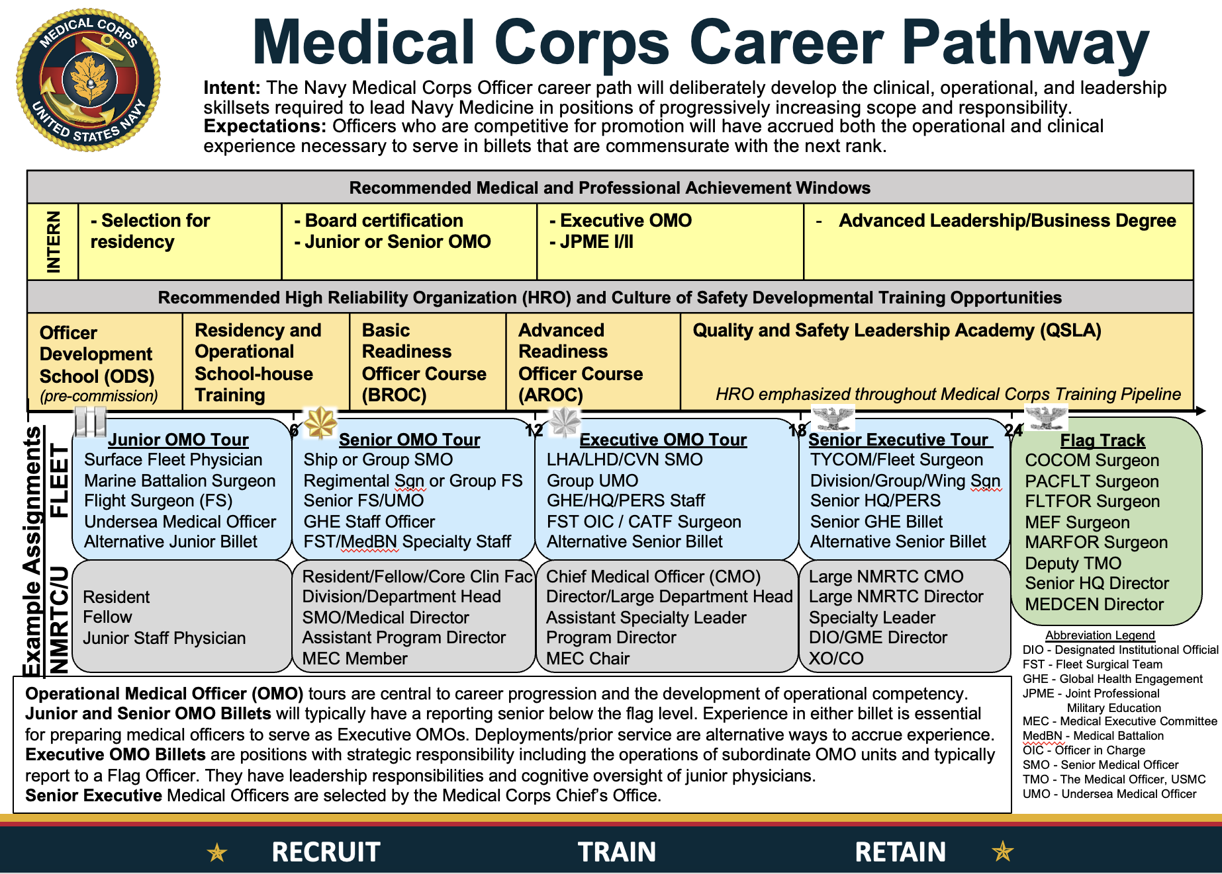

Many opportunities give you a desired rank (O5, for example) or range of ranks (O4-O5, for example). If you are one rank inferior or superior, you should consider applying. For example, if the desired rank is O5, anyone who is one rank below (O4) or one rank above (O6) should consider applying. I would not recommend an O3 apply because they are two ranks away.

I would also focus on opportunities that you think you’d enjoy or be good at, but preferably both. I would avoid applying if you don’t think you’d enjoy it or are not interested. For example, I don’t enjoy public health. I’m an Emergency Physician and prefer acute problems. As a result, I would not apply for public health related positions. There are many positions you can apply for, and I think you should avoid those that you would not enjoy or be good at.

Sometimes you’ll find yourself applying for positions, not getting them, and being pushed by your leadership in directions you did not anticipate or may not even want. In this case, you should probably read the room and take the position they want you to take. You may not think you’ll enjoy it or be good at it, but they want you to take it. I’d refer you back to the universal principle I started this chapter with and highlight that those who help their leadership advance their career. If you don’t take their advice or act on their recommendations, you may be putting your career at risk.

5 – SAVE AT LEAST 20%

You need to save at least 20% for retirement. This 20% is only for retirement and does not include saving for houses, cars, college, or any other large expenses. It is not adjusted down because you plan to stay in long enough to get a pension. That is why you are guaranteed to be wealthy if you just take this simple step. I started at 20% early in my career and gradually got to 30%. Plus, I have my pension. You can too.

To start, you need to find a way to track every dollar that enters your household. While you may be tempted to exclude allowances, I did not and would not recommend you do it either. Include literally every dollar that comes into your household and find a way to track it. You can consider using:

- Credit Karma
- EMPOWER
- Google Sheets
- Microsoft Excel
- Monarch Money
- Quicken
- ROCKETMoney
- YNAB

I use a Google Sheet that my wife and I share on Google Drive.

Once you have started tracking your inbound money, you need to come up with a way to make sure 20% of that gets invested for retirement. Optimally, you would automate it. A great book that talks about this is The Automatic Millionaire by David Bach. It is one of the books I read early in my career that set me on the right path, and I would highly recommend it. I will admit that I have only partially automated my investing.

The only automated portion of my investing is the Thrift Savings Plan (TSP). On a monthly basis I put in a high enough percentage of my basic pay that it fills my TSP in December. Aside from that, nothing is automated.

The way I invest my retirement money in my other accounts is manual. At the end of every month, I use the Google Sheets spreadsheet to calculate the total income for the month. I multiple that by 30%, my targeted retirement savings percentage. I then take that total retirement contribution and subtract whatever TSP contribution I made for that month. Whatever is remaining, I manually invest in my accounts at Vanguard.

For example, let’s say I made $20K last month. That means I need to save $6K for retirement because that is 30% of $20K. If I contributed $2K to the TSP, that leaves $4K to contribute for retirement outside of my TSP. If it is early in the year, I would put this money in one of our Vanguard Individual Retirement Arrangements (IRAs). Once they are full for the year, the money would go in a regular taxable brokerage account at Vanguard, my investing company of choice.

This is what you need to do every month. You need to total up all the money you make every month. Then you need to invest at least 20% of it for retirement. Remember that saving for cars, college, houses, or anything else is not included in this 20%. This 20% is only for retirement. One way to make this a little easier is to moonlight. Here is an article about moonlighting in the Navy.

It is a simple concept, but not one easily implemented. Who said getting rich was going to be easy?

6 – INVEST AGGRESSIVELY

You need to invest as aggressively as you can tolerate. What does aggressive investment look like? How do you know what your risk tolerance is? This is what we need to discuss.

The most basic investments are stocks, bonds, and cash. When you own stocks, you own pieces of those companies. You share in their profits (sometimes paid as dividends) and if the price of the stocks goes up, you make money when you sell your stocks. You also share in their losses. If a company goes bankrupt, that stock could become worthless. Over the long haul, stocks have produced larger investment returns than bonds or cash, but the swings in the price of stocks are also the largest. It is this variability in stock prices that make stocks riskier than bonds or cash, and why you are rewarded with a higher long-term return.

When you invest in bonds, you are loaning money to companies or governments. In return, they are paying you interest. If the company or government pays its debts, you get your money back plus interest. If you buy the bonds of high quality and reliable companies/governments, the rate of default (when a loan is not paid back) will be very low. In general, the investment return you earn on bonds will be lower than stocks, but the price of bonds will be more stable and less variable than stocks. That is why high-quality bonds are usually a lower risk investment than stocks.

Cash is the most conservative and least risky investment. You are putting your money in savings accounts, certificates of deposit, or money market accounts/funds. While the chances you lose your money is extremely low (and in some cases zero due to guarantees by the Federal Deposit Insurance Corporation), the interest you earn in cash investments is low and may not keep up with inflation, meaning you may lose purchasing power over the long-term.

What does it mean to invest aggressively? Stocks are the most aggressive investment. Bonds are intermediate risk, and cash is low risk. Investing aggressively means having the largest percentage of your investments in stocks that you can tolerate.

What do I mean when I say, “that you can tolerate?” You need to make sure that whenever the stock market suffers a significant decline, you can stick to your asset allocation. When the stock market falls, stocks are on sale, and you will need to invest more money in an asset class that is falling in price. Not everyone can tolerate watching the value of their investments drop without panicking and selling stocks while their price is down, much less putting even more money in a falling investment. Capitalizing on the falling stock market, though, is how you build wealth over the long-term.

For example, during the Great Financial Crisis (GFC) of 2007-2009, our own net worth was dropping precipitously. We were 100% invested in stocks, which dropped 50% during the GFC. Many people in a similar situation panicked and sold their stocks, but we did not. We continued to invest in stocks, purchasing more and more every month. Why not? Stocks were on sale. We have reaped the benefit ever since.

You need to invest as aggressively as you can, putting as large a percentage in stocks as you can tolerate. When the stock market crashes, you don’t sell stocks. You buy. For some people they will be able to do this while being 100% invested in stocks. For others, they will not and will need to have a lower percentage invested in stocks. Everyone is different. You just need to figure out your ideal stock to bond ratio.

How can you figure out a target asset allocation? There are a few easy ways. First, you can take this Vanguard survey. You can check out some financial books. One short book that is only about 130 pages and I recommend is The Elements of Investing by Malkiel and Ellis. This is the asset allocation they recommend if you tend to be more conservative:

AGE RANGE | STOCK % | BOND %
20-30s | 90-100% | 0-10%
40-50s | 80-90% | 10-20%

Here is what they recommend if you tend to be more aggressive:

AGE RANGE | STOCK % | BOND %
20-30s | 100% | 0%
40-50s | 90-100% | 0-10%

If you don’t want to worry about any of this, you can just use a target retirement fund like the TSP Lifecycle Funds. All major investment companies have their own versions. For example, here are Vanguard’s Target Retirement Funds. You just pick the name of the fund that contains the year closest to when you plan on starting to withdraw money from that account. For example, if you expect to need money around 2040, you will pick the TSP L 2040 Fund or the Vanguard Target Retirement 2040. The fund will start more aggressive and get more conservative automatically as you approach your target date when you expect to start withdrawing money.

Please note that while it is possible to use target date funds outside of a retirement account, you should avoid this. It may seem easy, but it can cause you tax problems.

What’s the bottom line? Pick the most aggressive asset allocation you can tolerate without panicking, buying more stocks when the stock market is crashing. Reap the rewards long-term.

7 - HOW TO CRUSH THE TSP

The Thrift Savings Plan (TSP) is the place you will put much of your aggressively invested assets. As a result, it is a good idea to make sure you understand the TSP and its various investment options. Here are the steps I recommend you take.

Step 1 - Prepare

Before you can crush the TSP, you must do a little preparation. You don’t need to be Warren Buffet, but you need to understand the basics of investing and the TSP. Luckily, there are many ways to learn the basics. Here are a few:

- Read a book – Go to your library, search for a used book with AddAll (one of my favorite tools), or buy a new one. The easiest and quickest read to increase your basic investing knowledge is The Elements of Investing: Easy Lessons for Every Investor.
- Read an online introduction to investing – The one that I’d recommend is the Bogleheads Wiki. Here’s a link to their getting started page and their investing start-up kit. What’s the best part? All of this is free.
- Watch videos – The Bogleheads have a video series, which is also free.
- Read blog posts – My favorite TSP-specific blog posts are found at The White Coat Investor. You can read What You Need To Know About The TSP, The G Fund – A Free Lunch, or The Military’s New Blended Retirement System. I wrote the last one.
- Read the TSP website – It has a wealth of information.

Step 2 - Decide

If you want to crush it with the TSP, you’ve got some decisions you must make. You must decide how much you’re going to invest and what investments you’re going to use.

To succeed, you need to invest as much as you can afford. How much can you contribute? Here is the TSP page that lists the contribution limits. This page may be confusing, so here is the bottom line:

- You can contribute $23,500 in 2025.
- If you are 50 or older at any time in 2025, you can contribute $7,500 in addition to the $23,500, for a total contribution of $31,000.
- If you are age 60 to 63 at any time in 2025, you can contribute $11,250 in addition to the $23,500, for a total contribution of $34,750.
- If you are deployed to a combat zone, you can contribute even more.
- If you are in the Blended Retirement System (BRS), any matching contributions you get from the DoD due to the BRS do not count toward these limits.

How much should you contribute? As much as you can. Period. Even a few hundred dollars is better than nothing.

When it comes to deciding which investments you are going to use, the TSP is pretty simple in this regard. You only really have six options.

The first option is to just let someone else handle this for you by using a Lifecycle Fund. According to the TSP:
The L Funds, or “Lifecycle” funds, use professionally determined investment mixes that are tailored to meet investment objectives based on various time horizons. The objective is to strike an optimal balance between the expected risk and return associated with each fund.

Using L Funds is a simple, easy, and effective strategy that is completely fine for most people. If that is how you want to do it, you can just put all your TSP money in the L Fund with the year that is closest to when you want to start pulling money out of the TSP and skip the rest of this chapter. For example, if you want to retire in 2034, you’d invest in the L 2035.

If you are more of a do-it-yourselfer, then you have five other investment options besides using a Lifecycle Fund. The five investment options can be compared in this table from the TSP website.

That is really it. You can either use a Lifecycle Fund, or one of the five other funds listed in the table. There is a way to invest in literally thousands of other investments via something called the TSP window, but because of the extra fees that are charged I don’t recommend this. You don’t need to invest in anything other than these basic options to achieve your goals, but if you want to invest in something else you can always do it in an Individual Retirement Arrangement (IRA) you set up at an investing firm like Vanguard, Fidelity, Schwab, etc., allowing you to avoid the extra TSP fees.

If you decided against using the Lifecycle Funds, the next thing you must do is determine your asset allocation.

Step 3 – Asset Allocation

You’ve probably heard that you shouldn’t put all your eggs in one basket. That is what asset allocation is all about…making sure your eggs are in multiple baskets.
Asset allocation can be complex. There are entire books written about nothing but asset allocation, like The Intelligent Asset Allocator: How to Build Your Portfolio to Maximize Returns and Minimize Risk. That’s a good book if you want to nerd out, but I’m going to try and simplify asset allocation for you because there are only five assets available in the TSP:
- G Fund – US government bonds specially issued to the TSP
- F Fund – US government, corporate, and mortgage-backed bonds
- C Fund – stocks of large and medium-sized US companies
- S Fund – stocks of small to medium-sized US companies (not included in the C Fund)
- I Fund – international stocks
If you want a detailed breakdown of each of these funds, you can find it on this page.
What is not available? There are a few major asset classes unavailable. You cannot invest in real estate or international bonds. If you want exposure to any of these asset classes right now, you’ll have to get them in your other investment accounts, like your IRA or taxable account.
How do you pick your asset allocation? If in step 2 you decided to use L Funds, you don’t need to pick an asset allocation for your TSP. The L Fund takes care of it for you.
If you are not going to use L Funds, one way to decide on an asset allocation is to take this Vanguard survey. At the top of the page it will give you a suggested allocation, such as 80% stocks and 20% bonds.
Another way is to borrow from trusted investment experts. Here are a few opinions.
In the first edition of the book The Elements of Investing: Easy Lessons for Every Investor, Burton Malkiel recommended these age-based asset allocations:
- 20-30s – bonds 10-25%, stocks 75-90%
- 40-50s – bonds 25-35%, stocks 65-75%
- 60s – bonds 35-55%, stocks 45-65%
- 70s – bonds 50-65%, stocks 35-50%
- 80s+ – bonds 60-80%, stocks 20-40%
In the same book, Charlie Ellis recommended these asset allocations:
- 20-30s – bonds 0%, stocks 100%
- 40s – bonds 0-10%, stocks 90-100%
- 50s – bonds 15-25%, stocks 75-85%
- 60s – bonds 20-30%, stocks 70-80%
- 70s – bonds 40-60%, stocks 40-60%
- 80s+ – bonds 50-70%, stocks 30-50%
Mr. Ellis is a little more aggressive than Mr. Malkiel because he recommends a higher allocation of stocks.
There are other ways to come up with a reasonable asset allocation, such as financial “rules of thumb.” The founder of Vanguard, John Bogle, is famous for creating the “age in bonds” rule of thumb. It says that whatever your age is, that is the percentage of your investments that should be in bonds. The rest should be in stocks.
For example, I’m 49 years old, so his rule would say I should have 49% in bonds and 51% in stocks.
This rule has been criticized as being too conservative, so some have changed it to 110 or 120 minus your age as the percentage you should have in stocks. For example, for me this would mean:
- 110 minus age 49 = 61% in stocks, the rest (39%) in bonds
- 120 minus age 49 = 71% in stocks, the rest (29%) in bonds (this is actually very close to my asset allocation in early 2025 of 70% stocks and 30% bonds)
There are certainly other ways to come up with your asset allocation. You could ask a financial advisor. You could read other books. You could read other blog posts, like this one on the Bogleheads Wiki.
How should you account for other assets like your military pension and social security? This is a tough issue. Some would argue that pensions and social security are income streams and that they should not play into your asset allocation decision. This is what Vanguard (my preferred investment company) argues. Others would argue that they are “bond-like” and should be factored into your asset allocation and counted as a large pile of bonds. Here are a few thoughts on the subject from blogs I follow and trust:
- The Oblivious Investor – How Pensions and Social Security Affect Asset Allocation
- Humble Dollar – A Price on Your Head
Somehow you must figure out your desired asset allocation. The info above will hopefully facilitate that. Once you have a target asset allocation, now you must apply it to the investments available in the TSP.
Step 4 - Invest

Just to make life a little easier, we’re going to use an example asset allocation of 80% stocks and 20% bonds.
For the bond portion of your asset allocation, you only have two investment choices:
- G Fund – US government bonds (specially issued to the TSP)
- F Fund – US government, corporate, and mortgage-backed bonds
Both are US bond options, which is just fine. There are no international bonds available in the TSP.
We could have an intellectual discussion about the subtle differences between these two bond funds, but we’re not going to. It isn’t necessary. They’re both fine bond funds, so just split the difference, diversify, and put half of your bond allocation in the G fund and half in the F fund.
To illustrate, in the example allocation of 80% stocks and 20% bonds, we’d put 10% in the G fund and 10% in the F fund.
That’s it. The bonds are done.
The stock allocation is a little more complicated. The largest decision you must make is how you’re going to divide your stocks between the three options. Here are your choices:
- C Fund – stocks of large and medium-sized US companies
- S Fund – stocks of small to medium-sized US companies (not included in the C Fund)
- I Fund – international stocks
The first question is what percentage of your stock allocation should go to the I fund. There are a few schools of thought on this.
John Bogle, the founder of Vanguard, is famous for believing that you don’t need to invest any of your stocks in international stocks. His long-held belief was that the US companies are doing business globally, so they are already worldwide diversified. For example, Coca-Cola is clearly selling Coke products all over the globe. He would say you should put 0% of your stocks in the I fund.
At the other end of the spectrum are people who believe that you should invest proportionally. If you look at the worldwide value of stocks, it is about a 50/50 split between the US and the rest of the world. These people would say you should put 50% of your allocation in international stocks.
Both opinions are reasonable, so anything between 0% and 50% allocated to the I fund is fine. What do I do?
I rely on the research done by Vanguard, an institution managing over $10 trillion. I figure they have more money and resources to research this stuff than I do. What does Vanguard do?
If you look at their Target Retirement Funds, which are meant to be a “one stop shop” kind of investment fund, you’ll notice that they split their stock allocation so that 60% is US and 40% is international. They used to do it 70% US and 30% international, but their research showed 60/40 to be a better split so they moved to it a few years ago.
You’ll notice that a 40% international allocation is between the 0% Bogle viewpoint and the 50% global weighting viewpoint, so it seems fine to me and that is what I do.
If you want another opinion, you can look at the TSP Lifecycle Funds. You’ll notice that they do about a 70% US and 30% international split, like Vanguard used to do. Again, that seems reasonable.
Ultimately, you can pick anywhere from 0% to 50% and find someone really smart who agrees with you. I’d encourage you to have some exposure to international, so I’d say you should pick at least 20%, but it really is up to you.
Not sure what to do? Go with 30% (the TSP Lifecycle approach) or 40% (the Vanguard approach) for the I fund and call it a day.
How do you divide between the C and S funds for your US stock allocation? This is easier, or at least I think it is. The C fund is basically an S&P 500 index fund of large companies, with the S fund having the rest of the small and medium sized companies. If you want to mirror the US stock market, you want to put about 75% of your US stock allocation in the C fund and the other 25% in the S fund. You’ll notice that this is what the TSP Lifecycle funds do, further backing up my assertion.
So, I recommend that you split your C and S fund allocation 75/25, respectively.
Putting the stock portion all together, here’s the math:
- (Your desired international stock %) X (your total stock allocation %) = % that goes in the I fund
- (Your total stock allocation %) – (% you are putting in the I fund) = % you must divide into the C and S funds
- (Your % you must divide into the C and S funds) X 0.75 = % that goes in the C fund
- (Your % you must divide into the C and S funds) X 0.25 = % that goes in the S fund
Let’s use the 80% stock and 20% bond example we started with to illustrate. Let’s assume we’re going with a 40% desired allocation to international (like I use):
- (Desired international stock = 40%) X (total stock allocation = 80%) = 32% goes in the I fund
- (Total stock allocation = 80%) – (32% that is going in the I fund) = 48% we must divide into the C and S funds
- (48% we must divide into the C and S funds) X 0.75 = 36% that goes in the C fund
- (48% we must divide into the C and S funds) X 0.25 = 12% that goes in the S fund
That gives us a stock allocation of 32% I fund, 36% C fund, and 12% S fund.
In summary, we split our bond allocation 50/50 between the G and F funds. We put the desired percentage for international stocks in the I fund. We split the remaining stock allocation 75/25 between the C and S funds, respectively.
For the 80% stock and 20% bond portfolio we are using as an example, this plays out:
- 10% in the G fund
- 10% in the F fund
- 32% in the I fund (based on a hypothetical 60/40 US/international stock split, which can vary as discussed above)
- 36% in the C fund
- 12% in the S fund
Step 5 – Roth vs Traditional

You must decide between the Roth vs traditional TSP. Let’s look at the difference between the two and help you to decide which is the right choice for you.
The traditional TSP is the first of two potential tax treatments for your TSP contributions. If you elect it, you defer paying taxes on your contributions and their earnings until you withdraw them. This is the only option for any money you get from the 5% government match in the new Blended Retirement System (BRS). Match money cannot go in the Roth TSP.
If you are in a combat zone making tax-free contributions, your contributions will be tax-free at withdrawal but your earnings will be subject to tax.
The Roth TSP is the second of two potential tax treatments for your TSP contributions. If you contribute to it, you pay taxes on your contributions now and your earnings are tax-free at withdrawal.
The Roth TSP is like a Roth 401(k) that a civilian would have, not a Roth IRA. There are no income limits for Roth TSP contributions like there are for Roth IRAs. You can contribute to both your Roth TSP and a Roth IRA without contributions to one affecting how much you can contribute to the other. For example, in 2025 you can contribute the full $23,500 to your Roth TSP and $7,000 to your Roth IRA.
Which is better for you, the Roth or traditional TSP? Here’s a table that compares the two options from the TSP website:
The Treatment of… | Traditional TSP | Roth TSP
Contributions | Pre-tax | After-tax¹
Your Paycheck | Taxes are deferred*, so less money is taken out of your paycheck. | Taxes are paid up front*, so more money comes out of your paycheck.
Transfers In | Transfers allowed from eligible employer plans and traditional IRAs | Transfers allowed from Roth 401(k)s, Roth 403(b)s, and Roth 457(b)s
Transfers Out | Transfers allowed to eligible employer plans, traditional IRAs, and Roth IRAs² | Transfers allowed to Roth 401(k)s, Roth 403(b)s, Roth 457(b)s, and Roth IRAs³
Withdrawals | Taxable when withdrawn | Tax-free earnings if five years have passed since January 1 of the year you made your first Roth contribution, AND you are age 59½ or older, permanently disabled, or deceased
* If you are a member of the uniformed services receiving tax-exempt pay (i.e., pay that is subject to the combat zone tax exclusion), your contributions from that pay will also be tax-exempt.
1. Roth contributions are subject to Federal (and, where applicable, state and local) income taxes, while traditional contributions are not taxed until withdrawn. However, both Roth contributions and traditional contributions are included in the amount of wages used to calculate payroll taxes (e.g., Social Security taxes).
2. You would have to pay taxes on any pre-tax amount transferred to a Roth IRA.
3. Transfers to a Roth IRA from a Roth TSP are not subject to the income restrictions that apply to Roth IRA contributions.

The issue of whether Roth is a good option for you was discussed in this TSP Highlights called Is Roth For You?
If you want to read what someone else thinks, I don’t blame you. Here’s an article from Humble Dollar.
The decision really boils down to whether you’d like to pay taxes now (Roth) or later (traditional) and how your current tax rate compares to your likely future tax rate during retirement. While predicting the future is not easy, if you are young or early in your career, your earnings and tax rate are likely to rise in the future, so you should probably lean toward the Roth option. If you are in your peak earning years and you expect your tax rate to fall in retirement, you should probably lean toward the traditional and defer taxes to a future date.
If you are not sure which option to choose, many people recommend you diversify your retirement accounts and simply split the Roth and traditional 50/50. That way in the future you’ll have options depending on how future tax rates and your financial situation changes.
What do I do? I can afford the taxes now and want as much tax-free money available to me as I can get, so I put all the money in the Roth TSP that I can. That said, the first part of my career I didn’t have a Roth option, so a large percentage of my TSP balance is in the traditional TSP as well, so I’m about 50/50 split between the two options.
There are some rules to be aware of. The TSP keeps your traditional and Roth money in separate “buckets” in your TSP account.
In early 2025, you cannot convert any portion of your existing traditional TSP balance to a Roth balance. The TSP has announced that this feature is coming at some point in the future.
You can make both traditional and Roth contributions if you want. You can contribute in any percentages or amounts you choose and can change your election at any time.
If you are getting government contributions (perhaps because you are in the BRS), they are deposited into your traditional TSP. You can put your portion in the Roth, but the government’s portion must go in the traditional.
Ultimately, you must use the resources above to decide if you want to invest in the traditional TSP, the Roth TSP, or some combination of the two. If you’re not sure what to do, I’d just split it 50/50 so you have options in the future.
Step 6 – Rebalance Annually

What is rebalancing? Let’s say that your desired TSP asset allocation is 80% stocks and 20% bonds. After the last year, though, stocks earned more than bonds and now you’re sitting at 90% stocks and 10% bonds. To rebalance back to your desired asset allocation, you’d sell approximately 10% of your stocks and buy bonds, restoring your desired asset allocation. It’s that simple.
If you don’t rebalance, you may be assuming more or less risk than you desire. Also, by rebalancing you force yourself to sell what has overperformed and buy what has underperformed. Although this seems counter-intuitive because you are selling what has given you the largest return, by doing this you are systematically selling high and buying low. When left to themselves, investors typically buy high and sell low, the opposite of what you want to do. Rebalancing forces you to do it right.
How often should you rebalance? Vanguard has researched this, and you can read their full report here:
Best Practices for Portfolio Rebalancing
Their conclusion is:
“We conclude that for most broadly diversified stock and bond fund portfolios (assuming reasonable expectations regarding return patterns, average returns, and risk), annual or semiannual monitoring, with rebalancing at 5% thresholds, is likely to produce a reasonable balance between risk control and cost minimization for most investors.”

In other words, you rebalance annually or semiannually (twice per year) whenever your current asset allocations are off by 5% or more from your desired allocations. If the current and desired allocations are within 5% of each other, you do nothing.
To rebalance in the TSP, you log on and do what they call a fund transfer. You can read all about it on this page from the TSP website.
Because you are doing it in a tax-advantaged retirement account, there are no expenses, fees, or taxes associated with rebalancing (unlike if you were rebalancing a taxable account).
You can only do it twice per month without restrictions, but since you are smart you are only doing it once per year anyway.
If you are using L Funds, you don’t need to rebalance. It is handled automatically. This is one of the major advantages of the L Funds.
The Easiest Way to Figure Out Your Optimal TSP Investment Plan
If after reading all the preceding info on the TSP you are confused or just want an easier path, here is the easiest way to come up with that plan.
Figure Out Your Asset Allocation
In the TSP, you can only invest in two broad asset classes – stocks and bonds. Because of this, the first decision you need to make is how you are going to divide your TSP among these asset classes.
To figure this out, take this Vanguard survey.
At the top of the page it will give you a suggested allocation, such as 80% stocks and 20% bonds. Jot this down somewhere.
Find the TSP Lifecycle Fund That Most Closely Matches This Asset Allocation
Here are the current broad asset allocations of the TSP Lifecycle Funds as of 12 APR 2025:
- L Income – 27% stocks, 73% bonds
- L 2025 – 28% stocks, 72% bonds
- L 2030 – 60% stocks, 40% bonds
- L 2035 – 66% stocks, 34% bonds
- L 2040 – 72% stocks, 28% bonds
- L 2045 – 77% stocks, 23% bonds
- L 2050 – 82% stocks, 18% bonds
- L 2055 – 99% stocks, 1% bonds
- L 2060 – 99% stocks, 1% bonds
- L 2065 – 99% stocks, 1% bonds
- L 2070 – 99% stocks, 1% bonds

You’re Done
Pick the one that is closest to your suggested asset allocation from the Vanguard survey. For example, if the survey said you needed 80% stocks and 20% bonds, I’d pick the L 2050 fund because it is closest.
Seriously, it is that simple. I’m not saying this is the best strategy, but it is the easiest and, in all honesty, if someone MADE me do this, I’d be fine with it. It is very reasonable way to approach saving for retirement, which is why I’m telling you about it.
Why do I make you take a Vanguard survey instead of just picking the Lifecycle fund that is closest to the year you want to retire? Because the Lifecycle funds are sometimes a little too conservative for my tastes and when you compare them with other target date funds.
If you want another pretty easy approach to saving for retirement, here is another easy method I came up with.

8 - THE G FUND

The TSP G Fund is a special fund you can’t get anywhere else. As a result, let’s take a look at two unique aspects of it, the G Fund “free lunch” and whether it is a cash asset or part of your bond allocation.
Will the Government Ever Get Rid of the “Free Lunch” of the TSP G Fund?
They say there’s no free lunch, but in the TSP there is a free lunch, and it’s called the G Fund. Will the government get rid of this free lunch?
The G Fund Free Lunch
What is this free lunch? Here is a quote from the TSP website:
“The G Fund Yield Advantage—The G Fund rate calculation results in a long-term rate being earned on short-term securities. Because long-term interest rates are generally higher than short-term rates, G Fund securities usually earn a higher rate of return than do short-term marketable Treasury securities.”
The government is paying you a higher interest rate than it should. That is the G Fund free lunch.
Why is the Free Lunch at Risk?
The government periodically considers getting rid of it. For example, the President’s FY19 budget plan/request proposed getting rid of it:
“G Fund investors benefit from receiving a medium-term Treasury Bond rate of return on what is essentially a short-term security,” the White House wrote. “The budget would instead base the G-fund yield on a short-term T-bill rate.”
At the time, TSP spokeswoman Kim Weaver said changing the G Fund’s yield would have a disastrous effect on participants’ ability to save for retirement. If Congress changed the G Fund to track the three-month Treasury bill, the interest paid would likely decrease.
“Such a change would make the G Fund inadequate and ineffective from an investment standpoint for TSP participants who are saving for retirement,” Weaver said in an email. “More than 3.6 million TSP participants (69 percent) have all or some of their account balance invested in the G Fund. Of those with money in the G Fund, 2 million (39 percent) hold the G Fund as their sole investment choice.”

For a TSP participant who has just retired and is invested entirely in the L Income Fund, which is designed for people who have begun taking annuity payments, they would run out of money at age 84 instead of the current projected age of 92, Weaver said.
Jessica Klement, staff vice president for advocacy at the National Active and Retired Federal Employees Association, said the change would make G Fund investments “useless” and likely force TSP administrators to divest from it entirely.
“[The new rate] would not even keep up with inflation,” she said. “So if you wanted to keep your money in a mostly secure fund, you would not be getting any return, and you’d actually be losing money. And if you took your money out, there would be no other safe, secure investment for those nearing or in retirement.”
What Does This Mean For You?
Right now, it means nothing. This is all just discussion about something that might happen in the future.
What you do need to understand, though, is that the G Fund serves a specific purpose in your portfolio. As the TSP site says:
“Consider investing in the G Fund if you would like to have all or a portion of your TSP account completely protected from loss. If you choose to invest in the G Fund, you are placing a higher priority on the stability and preservation of your money than on the opportunity to potentially achieve greater long-term growth in your account through investment in the other TSP funds.”
It is alarming that Ms. Weaver from the TSP said, “Of those with money in the G Fund, 2 million (39 percent) hold the G Fund as their sole investment choice.” Those 2 million people are sacrificing long-term growth for the safest and most conservative investment available in the TSP.
There’s nothing wrong with that if you’re doing it because you are very conservative, near retirement, or the G Fund serves as the bond portion of a larger, more diversified portfolio that has more risky assets like stocks.
The sad reality is that most who are solely invested in the G Fund are that way because it used to be the default option for those starting a TSP account, and they never switched it to a more aggressive investment option. Under the new Blended Retirement System, the default investment switched from the G Fund to an age-appropriate Lifecycle fund.
What’s the Bottom Line?
The G Fund gives you a free lunch, paying you a higher long-term interest rate while you are investing in short-term securities. The government periodically talks about getting rid of that free lunch.
If you are invested in the G Fund, make sure you are doing it purposely and are aware of its conservative nature. Its emphasis is on preserving wealth rather than growing wealth.
Does the TSP G Fund Count as a Bond or Cash in my Asset Allocation?
A blog reader wrote in and asked the following question:

“Hi there. I thoroughly enjoy your website! When determining what my current asset allocation is, should I consider the TSP’s G Fund as cash or as a bond fund? I have a Vanguard account, and their website shows you these great pie charts reflecting one’s asset allocation. But what’s the best way to think of the G Fund in this context? Thanks a lot!”
The Answer – It’s a Bond Fund
I can see why people might consider the G Fund a cash equivalent in their asset allocation, but I think it is best considered a bond because it is not liquid and is paying intermediate-term interest rates.
What is a cash equivalent? Here’s what Investopedia says:
“Cash equivalents are one of the three main asset classes, along with stocks and bonds. These securities have a low-risk, low-return profile and include U.S. government Treasury bills, bank certificates of deposit, bankers’ acceptances, corporate commercial paper and other money market instruments.”
The G Fund invests in “a nonmarketable short-term U.S. Treasury security that is specially issued to the TSP.” That makes it sound like a Treasury bill, which is listed as a cash equivalent above, but remember that the G Fund offers you a free lunch. It is a short-term security but the interest rate it pays is:
“…based on the weighted average yield of all outstanding Treasury notes and bonds with 4 or more years to maturity. As a result, participants who invest in the G Fund are rewarded with a long-term rate on what is essentially a short-term security. Generally, long-term interest rates are higher than short-term rates.”
In other words, it is really a hybrid between a short and long-term Treasury.
The other aspect of the G Fund that makes it a bond and not a cash equivalent is that it is not liquid. In other words, because it is in a retirement account you can’t sell it and use the proceeds to buy a car, deal with an emergency, or whatever else you need it for. Cash equivalents like CDs, money market accounts/funds, checking/savings accounts, or cold hard cash are all accessible and could be used for these purposes. Unless you are retirement age and withdrawing from your TSP account, the only way to get to the G Fund would be to take out a TSP loan, which I would not recommend.

9 – 7 STEPS TO FINANCIAL FREEDOM

Financial freedom is something everyone should strive for. Let’s go through the 7 steps I recommend to achieve financial freedom.

1st Step to Financial Freedom – Establishing an Emergency Fund

Bad things happen to good people. Houses burn down or flood. Cars get totaled. People are served unexpected divorce papers. Extended family members get huge medical bills that they can’t pay. You need to prepare for these unlikely but unanticipated events by keeping 3-6 months of living expenses in conservative investments that you can access in an emergency.

While most people recommend you accumulate an emergency fund, nothing is ever straightforward in the world of finance, and even something as bread-and-butter as an emergency fund can be controversial. Below are the aggressive and conservative approaches to establishing an emergency fund.

The Conservative Approach

There are many places you can park your emergency cushion. Savings or checking accounts are Federal Deposit Insurance Corporation (FDIC) insured and offer immediate access to your money, even via ATMs. The downside is that the historic yield on these investments usually does not keep up with inflation, so you lose purchasing power over the long haul. Money market mutual funds are probably the most recommended place to park your emergency reserves as they offer higher returns and allow you to write checks above certain amounts (commonly $250), giving you immediate access to the funds when you need them. Keeping emergency money in certificates of deposit is probably not a great idea, as you’ll pay a penalty if you access the money early.

Not all savings accounts or money funds are the same, and if you shop around you can find a better deal. For accounts offered by banks, check bankrate.com. For money market mutual funds, which are not FDIC insured but are almost as safe, check mutual fund companies. Commonly recommended companies include Fidelity, Schwab, and Vanguard (my favorite). Important things to look for are the minimum initial investment, the smallest amount you can write a check for, and the expense ratio (the lower the better). If you find yourself in a higher tax bracket, it may make sense to use a tax-exempt money market fund that invests in tax-free state and municipal bonds. These tax-exempt funds may offer a higher after-tax return, and some are targeted to the residents of states and offer state tax benefits as well. The mutual fund companies can usually help you decide which of their products is best for you.

The Aggressive Approach

The aggressive approach is to keep a smaller amount in reserve, 1-3 months of living expenses for example, and invest it more aggressively. You could keep 1/3rd of it in a money market fund, but the other 2/3^{rds} could be invested in a stock or bond fund or some combination of the two that will yield a higher return. This will allow your emergency fund to grow as your income grows, possibly reaching the recommended 6 months of living expenses or more. If you need more cash than what is in your emergency fund, anyone with reliable income can usually borrow the money by using a home equity loan, for example, or a credit card. Credit cards, obviously, have higher interest rates, but this is an aggressive approach, and you probably won’t have to borrow any money at all.

What Should You Do?

Only you can decide what is right for you. For example, as active-duty military I have full medical insurance for my whole family through TRICARE, and I have as much job security as anyone can have. I’m not getting fired (or at least I don’t think I am). As a result, my emergency fund sometimes resides in the low end of the 3–6-month range, as there are very few emergencies I expect to have to deal with. On the other hand, if I was a civilian and worked as an independent contractor, provided my own health insurance, and felt that my contract could be reduced or eliminated at any time, I’d probably have 6 months of living expenses (and maybe more) providing a more substantial cushion.

Whether you take a conservative or aggressive approach or somewhere in between, what is clear beyond a doubt is that you and your significant others need to come up with a plan for emergencies that makes sense for you and allows you to sleep at night.

2nd Step to Financial Freedom – Get Properly Insured

Having adequate insurance is a fundamental part of your overall financial plan and the 2nd step to financial freedom after establishing an emergency fund (perhaps it should even be 1st). It is also something that most people struggle with, as there are innumerable types of insurance with many options to choose from. At its most basic, insurance is a method to transfer risk from you to an insurance company, and you should only pay to transfer risks that you are not willing or able to shoulder. While insurance companies are happy to insure everyone and everything, in general you should only insure against large losses. Below is one man’s attempt to treat insurance with a “KISS” (keep it simple, stupid) approach. I will discuss insurance that you probably need, insurance you might need, and that which you probably don’t need.

Insurance You Probably Need

If you cannot afford the costs involved in any life scenario, then you should probably insure yourself against it.

Insurance

While an emergency fund and the Navy’s disability policy can “self-insure” you against short-term disability, you may need help in the event of a long-term disability unless you are wealthy enough that you can make up the difference between your military pay, including all bonuses, and your disability payments, which will not reflect the higher pay of anyone who gets significant bonuses. Most professionals probably rely on their higher pay and would be disappointed with the Navy and VA payments in the event of 100% disability, in which case you’d get approximately your annual/monthly basic pay.

Typically, you should obtain enough coverage to replace 60-70% of your income up to the age of 65 in the event of total disability. Ideally, the policy will cover your specific occupation, what is called “own occupation,” and will not rely on you finding alternative means of employment, such as working in a different occupation. You will also want coverage if you can only work part-time. Key components of the ideal policy include:
- Non-cancelable – they can’t cancel your policy or raise your premiums
- Guaranteed renewable – no medical exam is required to renew
- Residual benefit protection – pay you part of your benefit, or “residual benefits” if you are partially disabled
- Cost-of-living allowance – the amount you are paid is adjusted for inflation

If you think the Navy/VA disability payments would be inadequate, look for a private policy, which may be expensive and difficult to find while on active duty. After years of searching, I was able to get up to $2500/month of supplemental coverage from the American Medical Association. In addition, a private company called DI4MDs.com was able to get me the level of coverage I needed, although it was expensive (but not as expensive as being under-insured in the event I’m disabled).

Try to reduce the expense by lengthening your “waiting” or “elimination” period. The waiting/elimination period is the amount of time you must wait after becoming disabled until your disability payments begin. If you have a substantial emergency fund, you can lengthen your waiting/elimination period and lower your premiums. In addition, I figured it would take at least a year for the Navy to separate me if I was significantly disabled. If you don’t have a large emergency fund or feel the Navy will move fast in the event you are disabled, you may need a shorter waiting/elimination period and will likely pay higher premiums.

I have several posts about disability insurance for the military, which can be complicated and frequently changes. All the posts can be read here.

Homeowner’s Insurance

You need homeowner’s insurance to protect the structure of your house and its contents, and to insure against injuries to other people or damage to other people’s property. Make sure that the contents of your home are covered for “replacement cost” and not “actual cash value.” For example, replacement cost coverage will give you $600 to replace the 3-year-old laptop that was damaged, while actual cash value would only give you the $100 it is worth after 3 years. In addition, you will likely have to purchase a “floater” to cover any high-value items, such as jewelry or expensive art.

Renter’s Insurance

If you rent, you’ll need renter’s insurance to protect your belongings, but it also offers liability protection, like homeowner’s insurance.

Auto Insurance

You need auto insurance in case you have a serious accident and damage your car, injure yourself or others, or damage someone else’s property. Lower your rates by having a deductible on the policy that is as high as you can comfortably afford and carefully evaluate how much collision and comprehensive coverage you need. If you are driving an older vehicle that is not worth a lot of money, paying for this coverage may not make sense.

Umbrella Liability Insurance

Umbrella liability insurance protects you in case you get sued and adds liability coverage on top of your homeowner’s, renter’s, and auto insurance. It will come in handy if your dog bites someone and they develop a severe infection, the mailman slips and falls on your front porch and can no longer work, or a neighborhood child drowns in your pool. It is typically sold in $1 million increments and is relatively inexpensive. A $1 million dollar policy will typically run $150-300 per year. If you are a high income professional, you should have AT LEAST $1 million of coverage and should consider up to twice your net worth.

What if you are early in your career and have very few assets? You should still have umbrella liability insurance as future wages can be garnished in some judgments against you.

Insurance You Might Need

Professional Liability Insurance

If you are practicing medicine outside of the Navy (moonlighting), you need professional liability insurance. (If you don’t moonlight, you don’t need it.) This insurance will cover attorney fees, expert witnesses, court costs, costs of gathering evidence, and settlements in the event you are sued.

There are two types of policies, “occurrence” and “claims-made.” Claims-made policies only cover your liability if a claim is made before the policy ends. With this type of insurance, when you leave a job, you need to purchase “tail coverage” that extends your liability. Tail coverage can be expensive, and before you take a job moonlighting you need to make sure you know who is going to “pay the tail.” Occurrence policies are more expensive (and therefore less commonly offered) because they cover your liability in perpetuity and do not require a tail.

Life Insurance

“More money is wasted on life insurance than probably any other insurance product…It cannot be overemphasized that cash-value life insurance is probably one of the biggest scams around.” – Paul Sutherland in the AMA Physician’s Guide to Financial Planning (2008)

If you were to die, would anyone suffer financially? If the answer is “no,” then you don’t need life insurance. If the answer is “yes,” then you need life insurance, and probably a lot of it until you build your investment portfolio.

There are two types of life insurance. First, there are products that combine insurance with an investment account, often referred to as “cash-value” or “permanent” life insurance. Many insurance agents and companies (including USAA in my experience) will try to sell this, but it is probably not the kind of insurance you need. It does have some tax advantages, but the downside of these policies is that the insurance agent/company who sells them collects high fees. In addition, early premiums go mainly toward sales commissions and other expenses and not into your investment account.

The second type of life insurance is “term” insurance. It provides a death benefit only and does not build any cash value or serve as an investment. This is likely the only kind of life insurance that you need, and this is the type that Servicemembers Group Life Insurance or SGLI is. To quote again from the AMA’s financial planning guide, “I cannot emphasize enough the importance of sticking to simple, unencumbered term life insurance – it fits 99% of insurance needs.” It is less expensive than cash-value/permanent policies and you can take the difference and invest it in a retirement account or other low-cost investment vehicle. You don’t need an insurance agent to purchase this and should simply try term4sale.com, insure.com, or other similar websites. Both USAA and Navy Mutual Aid Association offer military-focused term life policies.

When you buy term insurance, ensure that it is renewable without a medical examination. You can also consider decreasing term insurance, where the death benefit progressively decreases. As you age, the need for life insurance typically declines as dependents age and your investment portfolio grows. Eventually you will need no life insurance at all, which is why many arguments for “permanent” life insurance should fall on deaf ears.

Long-Term Care Insurance

Sometimes called “nursing home insurance,” this is usually purchased by people over the age of 50 to pay for nursing or at-home care. If you are under 50, you should probably purchase disability insurance instead of long-term care insurance.

The rates and terms of these policies are highly variable, and whether you want to get one is an individual decision. The earlier you purchase it, the cheaper it is, but the total money you’ll pay out over the life of the policy is obviously higher. If you are a successful investor, you will probably have enough assets to self-insure in the event you need prolonged care, so I would suggest that most will not need this, but circumstances and goals obviously vary, so it is something to consider. If it is important to you that your nest egg is passed to your heirs, you may want to consider this insurance, so it is not passed to a nursing home instead.

Flood Insurance

Homeowner’s and renter’s insurance do not cover flood damage. To find out if your home is at risk of a flood, go to floodsmart.gov. There you can also find out information about the government’s low-cost flood insurance programs.

Earthquake Insurance

If you live in an area at risk for earthquakes, you’ll need earthquake insurance in addition to your homeowner’s insurance. California’s earthquake website, earthquakeauthority.com, is a good place to start.

Insurance You Probably Don’t Need

Supplemental Medical/Health Insurance

TRICARE has got you covered here, and there is no need to consider supplemental insurance until you retire.

Life Insurance for Children

While you will be sad if one of your children dies, you do not rely on his/her income; therefore, you are unlikely to need life insurance for children. The same thing is likely true for a spouse/partner who does not have a job, unless you would need money to replace the childcare he/she provides.

Rental Car Collision Insurance (Loss Damage Waiver)

They always ask if you want collision insurance or a “loss damage waiver” when you rent a car, but a lot of auto insurance policies automatically cover your rental cars. In addition, some credit cards provide this if you use their card to pay for the rental car, which is one reason you must use your government credit card for officially authorized rental cars. Make sure you find out if your policy or credit cards have this before you step up to the rental car counter and are put on the spot.

Flight Accident Insurance
If you need life insurance, buy it. Don’t buy insurance on a whim when purchasing tickets in the off chance that your plane goes down.

Travel Insurance

This is a common credit card benefit when you use them to pay for your trip, so check with your credit card company. Even if you don’t have it, it is unlikely to be worth your money for domestic flights.

Credit Protection Insurance

This is designed to protect your credit by insuring your credit card or mortgage payments in the event you become unemployed, disabled, or dead. If you have life or disability insurance, this is probably unnecessary.

Extended Warranties

Most products that offer extended warranties are not costly enough to insure with an extended warranty. If the new TV happens to break shortly after the warranty expires, you’ll probably be able to afford a new one. Most of these offers are a waste of your money.

General Insurance Advice

Insurance companies occasionally go under, so you want to make sure that you only get insurance from quality companies with strong financials and that you diversify your larger policies. You can find information on the finances of insurance companies from AMBest.com, FitchRatings.com, Moodys.com, and StandardAndPoors.com (NOTE: most of the sites require you to register to access their ratings). For example, if you need $2 million in life insurance, you should strongly consider diversifying and getting 2-3 different policies from various companies.

3rd Step to Financial Freedom – Debt Management

“Annual income, twenty pounds; annual expenditure, nineteen pounds; result, happiness. Annual income, twenty pounds; annual expenditure, twenty-one pounds; result, misery.” – Wilkins Micawber in David Copperfield

Debt has a bad reputation. It is prevalent, no one wants it, and everyone who has it wants to get rid of it. Everyone wants to be debt free.

There is, however, another way to look at debt. Debt is a financial tool to meet your personal and financial goals. For example, according to the Association of American Medical Colleges the median level of medical student debt was $200,000 in 2023. While we’d all agree that this level of debt is high, when necessary, it has allowed most medical students to meet their personal goal of becoming a physician.

Dealing with Debt Wisely

Banks and financial institutions see military officers as low-risk and are willing to loan us a lot of money, which can be good or bad. You can probably get a loan to buy a $100,000 luxury car, and while this might be fun, it is probably not wise. The same thing goes for a jumbo mortgage.

Every time you are considering a loan, you should ask yourself if what you are about to purchase is worth it. Will that fancy car or extra-large house truly bring you happiness? Or does it just bring a ton of overhead, increased expenses, and four extra rooms you’ll need to buy furniture for.

The book The Millionaire Next Door by Stanley and Danko was a longitudinal study of millionaires. This study showed that most millionaires don’t drive expensive cars. In fact, most drive “normal” cars or buy them used. In addition, most don’t live in large houses in expensive neighborhoods. Their study showed that physicians are notorious for buying these items to live up to society’s expectations. Doctors are supposed to drive luxury cars and live in expensive neighborhoods, right? This is also why they found that physicians under accumulate wealth and have much a lower net worth than their income would predict.

Do yourself a favor and buy a smaller house, drive a less expensive car, and avoid a boat. You don’t want to own the boat; you want to be best friends with the owner of the boat. Skip the vacation home. You can probably rent an equivalent home for much less than it would cost to buy it, and in 2013 the Nobel Prize in Economics was given to Robert J. Shiller, who showed that housing prices barely outpace inflation over the long haul, making real estate a less attractive investment.

While the goal is to get to the point where you can pay cash for cars and other major purchases, you will likely take out loans for some period when a major need arises. Here are some financial rules of thumb to keep you from getting in debt beyond what you can handle:
- Monthly debt payments (excluding your mortgage) should be <20% of your monthly income.
- Your housing costs should be <30% of your income.

No matter what debt you accumulate, make sure you always make your payments on time. The #1 factor that goes into calculating your credit score is your ability to make timely payments on your debt, and your credit score will determine the interest rate you are charged on nearly every loan you ever take. One late $50 payment could cost you thousands of dollars on a mortgage, for example.

Credit Cards

“Keeping a balance on your credit card is about the worst financial move you can make.” – Burton G. Malkiel, Chair of Economics, Princeton University, Author of A Random Walk Down Wall Street

The quote above says it all. If you are going to use a credit card for the convenience, always pay off the entire balance every month because the interest rates they charge can be very high. If you can’t control your credit card debt, cut them up, cancel them, or only have one that you use in special circumstances. If you must keep credit card debt, make sure you ask your credit card company to lower the rate or transfer the debt to a low-rate card. Check credit.com or cardrates.com for a list of low rate cards. Also, you can try calling your credit card companies, reminding them you are in the military, and ask them to hold to the Servicemembers Civil Relief Act (SCRA). I know multiple people who have received hundreds if not thousands of dollars back from their credit card companies when they called about the SCRA.

Good Debt?

In addition to helping you achieve financial goals that are important to you, debt can be used to limit the amount of your own investments that must be in cash equivalents. Having easy access to credit can provide a nice backstop in case of a sudden need for cash.

If you have equity in your home, a home equity line of credit can serve this purpose. Their interest rates are usually low, and the interest is often tax deductible, further lowering the cost of borrowing. Home equity lines of credit (and other lines of credit as well) should be set up in advance, not after you or your spouse/partner loses their job, and you are a credit risk. Beware of fees your lender may charge and see if you can find one that will waive them for a slightly higher interest rate. A slightly higher interest rate isn’t that big of a deal as you hope to never use this line of credit anyway.

Student Loans

Despite military scholarship programs or free service academies, many readers will have significant student loans. Since I never had student loans, I will admit that this is a weak area in my financial knowledge. By far the best source for information on student loans, paying them off, getting them forgiven, and refinancing them is The White Coat Investor. I would STRONGLY ENCOURAGE anyone, especially those with student loans, to check out this resource. It is unparalleled and the most useful financial site for high income professionals on the web.

For physicians and dentists reading this, probably the most important step they can take to pay off their student loans is to avoid jumping straight into the “doctor lifestyle” as soon as they graduate. If you continue to live like a trainee until your student loans are paid off, it shouldn’t take more than a few years to get rid of them, after which you can splurge a little and enjoy your income free of student loans. This is easy to type and hard to do, but just a few years of “roughing it” can wipe out your student loans.

Paying Off Debt

When you pay off debt, you are earning an after-tax return equivalent to the interest rate you are being charged. For example, if you pay off credit card debt with an 18% interest rate, this is the equivalent of earning a guaranteed 18% return on your investment tax-free. With the long-term rate of return for the stock market averaging just under 10%, you can see that paying off high-rate debt is often a better move than investing in the stock market. In other words, it makes no sense to pay the minimum on high-interest debt like credit cards while investing in the stock market. Pay off your high interest debt first.

The one exception to this is if you get an employer match on your retirement account contributions. If you get a match, that is an immediate return on your investment, so contribute to your retirement account up to the maximum that your employer matches, then pay off high interest debt. People in the military’s Blended Retirement System get a match in their TSP.

If you have multiple loans, pay off the one with the highest interest rate first. In addition, see if you can stretch out the payments for your low interest loans over a longer period, lowering your monthly payments and freeing up cash to pay off your higher interest debts faster. For example, if you have credit card debt with a 14% interest rate, a car loan with an 8% rate, and a mortgage with a 5% rate, pay off the credit card first, then the car loan, and then the mortgage.

Keep in mind that it often doesn’t make sense to pay off debt when the interest rate is lower than the after-tax rate you could earn on an investment. If you want a number, I would pay off high-interest debt (rates greater than 6-8%) such as credit cards, car loans, and private educational loans. If the rate is less than 6%, it probably makes more sense to invest the money in mutual funds and pay off the debt as slowly as possible.

Another move to consider is to take out a home equity loan to pay off high interest debt. You get a lump sum with a fixed interest rate that is often lower than your current debt and pay it off over 5-15 years. In most cases the interest you pay is tax deductible. Keep in mind that you could lose your house if you default on this type of loan and beware of any up-front fees that you need to factor into your calculations.

The Debt Management Bottom Line

Don’t wait until a crisis hits (divorce, job loss, disability, or a lawsuit) to get your debt in order. If you have major problems with debt and need help, seek a fee-only financial planner with experience who can help you restructure and manage your debt.

4th Step to Financial Freedom – Contribute Maximally to Your Tax-Favored Retirement Accounts

The benefits of a tax-favored retirement plan like the TSP or an Individual Retirement Arrangement (IRA) are too great to ignore. Over the span of your career, sheltering your investment earnings from the taxman will benefit you tremendously. For example, assume that you make a $4,000 annual contribution for 45 years and earn an 8% annual return. Here is how much you would have if you invested in a taxable investment account versus a tax-deferred account:
- Taxable investment total – $604,407
- Tax-deferred investment total – $1,669,670
As you can see, the power of keeping your investment returns and not paying taxes on them can lead to huge differences in the amount of investment growth you will experience.

The primary tax-favored investment account that is available to us is the TSP. If possible, you should always contribute the maximum amount each year, which is $23,500/year in 2025. If you will turn 50 in 2025 (like me), you can contribute an additional $7,500 for a total of $31,000. If you will be age 60-63 (not me), you can contribute an extra $11,250 for a total of $34,750. You may be able to contribute even more.

After you fill your TSP, open an IRA and, again, contribute the maximum amount each year. The contribution limits for 2025 are $7,000/year ($8,000/year if you are 50 or older).

For both the TSP and IRA you’ll face the decision of whether to contribute to a Roth or traditional version. Roth contributions are taxed now, meaning you make after tax contributions and future withdrawals are tax free. Traditional contributions are taxed when you withdraw, meaning you make pre-tax contributions now and pay taxes later. For younger or military people, the Roth is usually more advantageous because your tax rate is lower than it will be in the future, but there are many on-line calculators to help you decide which option is best for you. Here is a page from Vanguard that compares the two types of IRAs. The TSP page that discusses the two options is here.

The Roth IRA does require an adjusted gross income of less than $150,000/year (single) or $236,000/year (married) in 2025 to fully contribute, but there is a way around this called a “backdoor” Roth IRA. For a tutorial on how to do this, go to this White Coat Investor post.

If you moonlight as an independent contractor (you’ll know because you will be paid with a Form 1099), you will have other tax-favored options available to you, including a SEP-IRA or Solo 401k. In these accounts you can often contribute a lot more money. For a full discussion of them see this White Coat Investor post.

The bottom line is that to maximize your net worth you need to maximize your contributions to all tax-favored retirement accounts you have available to you. Hiding your investment earnings from the taxman will allow you to accumulate a lot more for retirement.

The 5th Step to Financial Freedom – Invest in Stock and Bond Index Funds

Investing in stock and bond funds (not individual stocks and bonds) is the simple way to get higher investment returns than more conservative investments like bank accounts, money market funds, or certificates of deposit (CDs). By owning stock funds, you own businesses, and the long-term return of these businesses is what will increase your investments and net worth. In addition, it is the only way you can invest and stay ahead of inflation.

If you put your money in a savings account that earns 1% but inflation is 3% that year, you just lost 2% of purchasing power. With a historical inflation rate of approximately 3%, you can’t even keep up with inflation and break even without taking some risk and earning a return of at least 3%. The long-term return of the stock market is approximately 9.5% per year. According to a great book written by John Bogle (the founder of Vanguard), adjusting for 3% inflation, $1 of purchasing power invested grows to:
- $1.88 in 10 years
- $3.52 in 20 years
- $6.61 in 30 years
- $12.42 in 40 years
- $23.31 in 50 years

When it comes to selecting stock and bond funds, you will have to look at the investments offered by your financial institutions and select from that menu. The principles to guide you should be:

- Favor index funds over actively managed funds. An index fund is a fund whose goal is to mirror the performance and composition of a standard basket of investments, like the Standard & Poor’s 500 (S&P 500) Index. An actively managed fund means that a fund manager is buying/selling investments as they see fit to beat “the market” or a comparable index. We’re investing for the long-term, and over this time frame almost no actively managed funds will beat their index. In addition, because past performance does not predict future performance, there is no way to predict which of these very few active funds will beat their index. Index funds are low cost, tax efficient, simple, and give you a higher return. Don’t try to beat the market, join it by investing in index funds.
- Favor mutual funds with low expense ratios. What is an expense ratio? An expense ratio is the percentage of a fund’s assets that is used for expenses. In other words, if you invest in a mutual fund with a 1% expense ratio and that fund makes 10% in a year, you’ll only get a 9% return on your investment because 1% goes to pay expenses. The less of your return you use to pay expenses, the more you get to keep.

What is an average expense ratio? An average stock mutual fund has an expense ratio of about 0.5%, but the expense ratios for mutual funds that are similar in their composition can vary wildly. For example, if you look at a list of S&P 500 index funds offered by investment companies, you’d find expense ratios as low as 0.015% (The Fidelity 500 Index Fund, FXAIX) and as high as 0.51% (Empower S&P 500 Index, MXVIX). While 0.495% does not seem like that large of a difference, keep in mind that costs last forever and that small differences compounded over years will cost you a lot of money.

The expense ratio for funds you choose to invest in should be less than 0.25%. If you want to keep this easy, just invest in the index funds offered by the Thrift Savings Plan (TSP) or Vanguard as they all meet these criteria.

As previously discussed, to beat inflation over the long haul, you’ll need to invest some of your portfolio in stock index funds. Investing in stock and bond funds is not for the weak hearted because you can lose money. Over the long term, though, assuming higher risk leads to a higher return. As you progress toward retirement, you will decrease your investment risk by decreasing the amount you invest in stocks and increasing the amount you invest in bonds.

The optimal asset allocation of investments depends on your age, financial situation, risk tolerance, and how soon you will need to utilize the investment. If you are young, you have longer to ride out the inevitable market swings. The more financially secure you are, the better you can deal with the swings as well. Your asset allocation should also reflect the amount of risk tolerance you have. You should take as much risk as you can tolerate. If you can’t sleep at night because you are worried about your investments, it is time to dial down the risk, but you should take as much risk as you can up to that point. More risk yields a higher return over the long-term.

Several guidelines for asset allocation from trusted references are discussed below:

Malkiel & Ellis suggest this as a conservative asset allocation:

AGE GROUP | PERCENT IN STOCKS | PERCENT IN BONDS
20-30s | 75-90 | 25-10
40-50s | 65-75 | 35-25
60s | 45-65 | 55-35
70s | 35-50 | 65-50
80s+ | 20-40 | 80-60

They also suggest a more aggressive asset allocation, which is my personal favorite due to the protection offered by our inflation adjusted military pension (assuming you stay in for 20 years):

AGE GROUP | PERCENT IN STOCKS | PERCENT IN BONDS
20-30s | 100 | 0
40s | 90-100 | 10-0
50s | 75-85 | 25-15
60s | 70-80 | 30-20
70s | 40-60 | 60-40
80s+ | 30-50 | 70-50

John Bogle, the founder of Vanguard, suggested a conservative asset allocation rule that your percentage of assets in bonds should equal your age. In other words, at age 30 you should have 70% in stocks and 30% in bonds. A more aggressive version is to subtract 10-20 from your age, so at age 30 you’d have 80-90% in stocks and 10-20% in bonds. My current asset allocation is almost exactly the most aggressive version of this rule. I’m age 50, minus 20, leaving me 30% in bonds.

One very easy way to let someone else make this decision for you is to pick target retirement funds as your investments. Many investment companies offer these, including the TSP and Vanguard. You just pick the approximate year you plan to start using the money, that year will likely be in the name of the fund (Target Retirement 2035, for example), and invest in that fund. Your investments will gradually get more conservative as you age without any action on your part. Just make sure that the target date funds you use are composed of index funds with low expense ratios (again, using the TSP or Vanguard funds makes this a no-brainer). A target retirement fund composed of actively managed funds with expense ratios greater than 0.5% is a target retirement fund to avoid.

When investing you need to keep this truth in mind…the market will go down, and when it does you need to resist the temptation to sell investments or stop investing. The best time to buy an investment is when it is cheap, and you can get the best deal. When the market recovers, which it will, you will reap the rewards. Focus on the long-term and just keep investing.

Every time you get a raise, bonus, or income tax refund, use it to increase the amount you invest for retirement. You should save at least 15% of your gross or pre-tax income for retirement, but if you want to be rich or retire early, you’ll need to save 20-30%. If you find it difficult to save, set up an automatic investment plan so that the money is automatically removed from your pay, and you never get a chance to spend it. The TSP makes an automatic investment plan easy to implement.

6th Step to Financial Freedom – The Rent vs Buy Real Estate Decision

The classic advice has always been to purchase your home if you can afford it, but in the military the decision is much more complex. You can’t simply compare your rent versus a mortgage payment. You must consider tax breaks, fees associated with purchasing real estate, maintenance costs, and how long you expect to stay at your duty station. Here’s a breakdown as I see it:

Benefits of Home Ownership

- Interest payments and property taxes are deductible.
- When you sell, gains on home value are federal tax exempt up to $250K if single and $500K if married.
- Making regular mortgage payments forces you to save.
- You can get some significant asset protection as many states protect home equity from lawsuits.
- As you make mortgage payments and accumulate home equity, it serves as a diversifier in your investment portfolio.
- Real estate is a great hedge against inflation and is only moderately correlated with traditional investments like stocks and bonds.

Downsides of Home Ownership

- Most home purchases have a 3-5 year break even period, which just happens to coincide with the length of most residencies and military tours of duty.
- Real estate appreciation barely keeps up with inflation over the long haul.
- Sudden moves can force you to either sell your house or become a landlord.
- The classic teaching is that purchasing a home is a great investment because you don’t have to pay rent, but buying a home that is too expensive will harm you financially because of all the associated costs, such as heating, cooling, insurance, maintenance, buying, and selling. Expect to pay 5% of the value of the house when buying it, 1-2% of the value each year to maintain it, and 10% of the value when selling it.

Benefits of Renting

- You avoid the fees and ongoing expenses associated with buying, maintaining, and selling a home.
- Rental contracts have military clauses that will allow you to get out of a lease in the event of a sudden military directed move.
- In high-cost areas (Hawaii and San Diego are frequent duty stations that fit this description), it is often much more affordable to rent than to buy.

Downsides of Renting

- You don’t get the benefits of home ownership listed above.
- It is not the “American dream” of homeownership.

Rent vs Buy Calculators

You don’t have to make this decision on your own. There are on-line calculators to help you make your decision.

The reality is that this is a very personal choice, and there really isn’t a right or wrong answer. What you should do will be based purely on your personal values and likely career path. My personal bias would be to make sure that by the time I retire I have paid off the mortgage on my primary (and hopefully only) residence.

7th Step to Financial Freedom – Saving for Future College Expenses
The 7th (and optional) step to financial freedom is to save for future college expenses.
Only a small percentage of students get enough financial aid to cover their tuition, housing, books, and fees. As a result, saving for college is a major financial goal for many people. Luckily, it is as easy as 3 numbers…5-2-9, as in using a 529 plan. 529 plans allow parents or grandparents to put money aside in a tax advantaged way that can later be used for college. In addition, those of us in the military who are willing to serve a little longer can transfer our GI Bill to our children, which can help with college costs, sometimes covering them completely. I’ve got two kids and used our two GI Bills to cover all their undergraduate expenses.
How Expensive is College?
According to the National Center for Education Statistics:
“In 2022–23, the average total cost of attendance for first-time, full-time undergraduate students living on campus at 4-year degree-granting institutions was higher at private nonprofit institutions ($58,600) than at private for-profit institutions ($33,600) and public institutions ($27,100).”
How Can You Limit Costs?
Get your kids to go to a state or public school. Once you’ve got your degree and are working, no one really cares where you went to school. Work ethic, intelligence, creativity, and other characteristics make or break your success, not an Ivy League pedigree. State schools are probably just fine.
One other strategy is to have your kids go to a community college for the first 1-2 years of their education, later transferring to a four-year college or university and getting their degree.
529 Plans
The money in 529 plans can be invested in stock and bond funds. If the withdrawals are used for qualified higher educational expenses, the investment gains are free from federal taxation.
As of 2025, you can contribute as much as $19,000 per year to each child without incurring the federal gift tax. In addition, you can pre-fund up to 5 years of these contributions, or $95,000 in 1 year. Couples can give $190,000.
Does this sound too good to be true? Well, it is true, which is why 529 plans have come to dominate the college saving game.
Downsides of a 529 Plan
If you don’t use the proceeds of your 529 plan for educational expenses, your gains are subject to income tax and a 10% penalty. In addition, colleges will consider 529 assets when determining need-based financial aid. If you believe you’ll be eligible for financial aid, you might be better off keeping the assets in your name or the names of the grandparents.
That said, the amount you’ve saved for college has much less of an impact on your financial aid than your overall income does. In other words, families with high incomes will be expected to pay for at least part of college regardless of whether they saved for college.
As Usual, Taxes and Costs Matter
Not all 529 plans are perfect. Each state offers a plan, and you can use the plan from any state. You are not limited to the one you live in.
There may be some state tax benefits if you use your state’s plan but just like with all investments you must see if those tax benefits outweigh the other features of the plan. Some states have high fees and expenses or have less than optimal investment options. Some states give you tax benefits no matter which states’ plan you use.
Which 529 plan do I use? Many would guess that I use whichever state’s plan is run by Vanguard, and they’d be correct! Vanguard administers the Nevada plan, which is what I use. Many states, though, offer Vanguard investments and other low-cost investment options.
You find a lot of good information on 529 plans at:
http://www.savingforcollege.com/
Other Types of Accounts
There are other ways to save for college other than a 529 plan. A page from Vanguard’s website discusses some of the other options.
While there are other options, I believe the 529 offers the most benefits. Some people advocate using Roth IRAs, whole life insurance, or ultra-conservative investments like certificates of deposit (CDs) or savings accounts, but this is generally a bad idea.
You need your IRAs to save for retirement, not college. Saving for retirement is your top priority, even over funding the college education of your children. You can borrow money to pay for college, but you can’t borrow money to retire.
Life insurance is expensive and generally offers very low investment returns. CDs and savings accounts aren’t expensive, but their investment returns are just as anemic. With educational inflation at 6% annually, it will be hard enough for stocks and bonds to keep up let alone life insurance or CDs/savings accounts.
The GI Bill
If you have served in the military after September 11, 2001, you are eligible for the Post-911 GI Bill. It covers four academic years, including tuition and fees, housing, and books up to 100% of the cost of the most expensive public school in your state. For private schools in 2024-2025, it will cover up to $28,937.09 of costs. Some more expensive schools participate in the Yellow Ribbon Program to bring their tuition down closer to what the government will pay.
If you have served at least 6 years and are willing to serve 4 more, you can transfer the GI Bill to your spouse or children. We used our Post-911 GI Bills to pay for two private undergraduate educations for our children that exceeded the tuition limit at the time. Because of the Yellow Ribbon Program, we paid no additional tuition.
You can find a ton of information on the GI Bill at this website:
http://www.military.com/education/gi-bill
Specific information about transferring your GI Bill is here:
http://www.military.com/education/gi-bill/post-911-gi-bill-transferability-fact-sheet.html
What’s the Bottom Line?
529 plans have become the go-to account for most people saving for college. Go to SavingForCollege.com to find out which state’s plan is right for you. If you have a GI Bill and are willing to transfer it to your children for their future college expenses, check out the link above for all the details

10 - CONCLUSION

To become a wealthy Captain, you need to take these five steps:

- Stay out of trouble and avoid any “red flags” on your record.
- Actively manage your career and record.
- Volunteer to help your leadership whenever they need it.
- Save at least 20% of all your income for retirement.
- Invest as aggressively as you can tolerate.

That really is it. It is simple to read, but not necessarily easy to do. That said, it is possible. And while there are many roads that can make you a wealthy Captain, this is the road I took and recommend.

ABOUT THE AUTHOR

CAPT Joel Schofer is board certified in Emergency Medicine and currently serves as the Commanding Officer of USNMRTC Guam and the Director of US Naval Hospital Guam. He is a recovering Detailer, Specialty Leader, and Deputy Medical Corps Chief, but is mostly known as “the guy with the blog” (MCCareer.org). He is a Certified Physician Executive, has over 200 professional publications and presentations, has held numerous national and state leadership positions, and has won national academic and educational awards. He holds an academic appointment as an Associate Professor of Military and Emergency Medicine at the Uniformed Services University of the Health Sciences. He is a Fellow in the American Academy of Emergency Medicine and American Association for Physician Leadership. His military decorations include the Combat Action Ribbon, a Legion of Merit, a Defense Meritorious Service Medal, three Meritorious Service Medals, and four Navy and Marine Corps Commendation Medals.

