FY27 Promotion Talking Points for MSC

Overall view
- Goal of the promotion plan is to ensure sufficient inventory of control grade officers are available to meet Navy manpower requirements across the FYDP.
- The promotion plan is built to maintain opportunity and flow point within OSD and SECNAV guidelines and provide projections across the FYDP.
- The annual promotion plan is endorsed by CNP and CNO and approved by SECNAV.
- The FY27 promotion boards are held in FY26 but the year of execution is 2027.
- Service members should ensure their records are board ready.
- Proposed plan includes similar opportunity to FY26 plan with robust selections at all grades, especially LCDR. This plan was designed to attain higher retention and N-1 directed medical manning mandate (98% of pre-divestiture BA).
- Defense Officer Personnel Management Act (DOPMA)
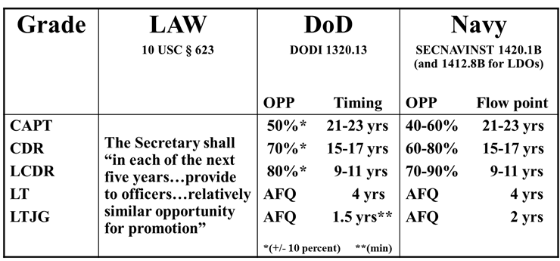
Higher opportunity results in a smaller zone and increases flow point
Lower opportunity results in a larger zone and decreases flow point
- Medical Corps and Dental Corps are not DOPMA constrained however Nurse Corps and Medical Service Corps are routinely DOPMA constrained.
- FY27 proposed promotion plan is an exception to this DOPMA constrained policy due to increases in the authorized billets and in the setting of decreased manning.
- NAVADMIN has important info for members who have not been on AD for one year at the time the board convenes.
- Due to increased Direct Accessions with Entry Grade Credit and more senior INDEF RECALLs, members who have not been on AD for one year at the time the board convenes will not be considered unless they request a waiver of deferment
- December’s NAVADMIN releasing zones publicizes this eligibility requirement and the need for a waiver to be considered. MyNavyHR Sample Waiver of Deferment
- Expect Lineal List to have names marked RETIRE/RETAIN and Above Zone Not Previously Considered (AZ NPC).
- Active O6 (#170) Staff board convenes 10 February 2026.
- Active O5 (#265) and O4 (#300) Staff board convenes 4 May 2026.
- “90-day rule” from 10 USC 619(c)(2)(C) excludes from consideration any officer who is separating within 90 days after the board convenes.
- Medical OCMs submitted for an Exception to Policy (ETP) requesting all Medical communities be exempt from 90-day rule – OPNAV and OJAG support ETP.
Definitions:
- Flow point: Average years of service when a due course officer is promoted to the next grade
- Opportunity: The in-zone “possibility” of selection
- Selection Rate: Percentage of all officers selected for promotion
Selections (AZ + IZ + BZ)
Total Officers IZ
- Max below zone 10% (SECNAV statutory limit); no above zone limits (by law or policy)
- Due Course: Officers who have not failed to select or select below zone
- Above Zone Not Previously Considered (AZ NPC): An officer who is senior to the senior in zone, but who has not been previously considered for promotion
- Control grade officers are so named due to statutory “controls” (i.e., limits), delineated in 10 USC §523, which limits the number of officers in the grades of O4, O5, and O6 that may be serving on active duty based on total the size of the officer corps
- Medical Service Corps
  - 2xFOS LT Continuation: Proposed plan offers 2xFOS LT Continuation as a safeguard so that no 2xFOS LT is involuntarily separated.
  - Statutory time-in-grade and flow point are the limiting factors.
  - Retire/Retain opportunities available.
  - For context the 5-yr trend (executed promotion) is below:

