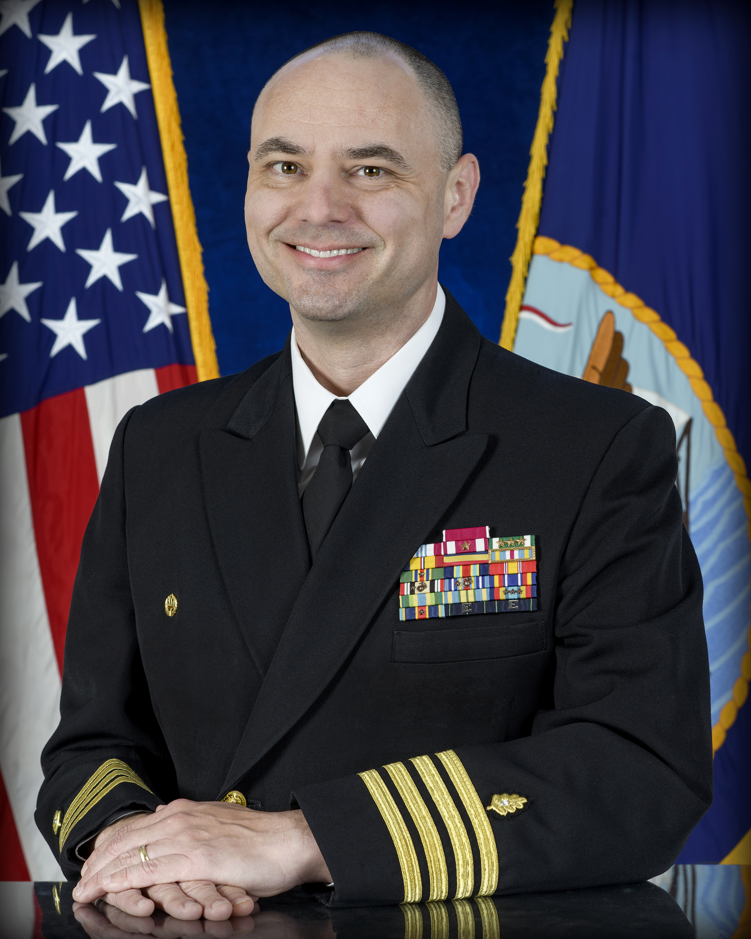
JOEL M. SCHOFER, MD, MBA, CPE, FAAEM, FAAPL

CAPTAIN, MEDICAL CORPS, US NAVY

CAPT Schofer is a native of Boyertown, Pennsylvania, and received his Bachelor of Science from Ursinus College. Commissioned in 1997, he earned his Doctor of Medicine from MCP Hahnemann School of Medicine in 2001. He completed his Emergency Medicine residency as Academic Chief Resident at Naval Medical Center San Diego in 2006 and a fellowship in Emergency Ultrasound at Christiana Care Health System in 2009. He received his Executive Master’s in Business Administration from the Naval Postgraduate School in 2014. He is also a graduate of the Naval War College Fleet Seminar Program (Joint Professional Military Education or JPME I) and Joint and Combined Warfighting School, Joint Forces Staff College, National Defense University (JPME II).

CAPT Schofer has served in a number of operational roles. In 2002, he served as a General Medical Officer with the United States Marine Corps, Camp Pendleton, California, where he deployed in support of Operation Enduring/Iraqi Freedom I. In 2010, he deployed as an individual augmentee with the 15th Marine Expeditionary Unit aboard the USS Pearl Harbor. From 2015 to 2016, CAPT Schofer served as the Commander of the Joint Medical Group and Joint Task Force (JTF) Surgeon, JTF GTMO. From 2018 to 2019, he served as the Executive Officer of Expeditionary Medical Facility Juliet.

CAPT Schofer has also served in numerous leadership positions at military treatment facilities. From 2006 to 2008, he served as a member of the Executive Committee of the Medical Staff at US Naval Hospital Okinawa, Okinawa, Japan. From 2009 to 2014, he served as Emergency Ultrasound Director, Fast Track Director, Emergency Department Senior Medical Officer, Associate Director of Medical Services, Physician Advisor for Quality Management, and Chairman of the Performance Improvement Committee at Naval Medical Center Portsmouth. From 2016 to 2019, he concluded another tour at Naval Medical Center Portsmouth where he served as the Acting Chair of the Emergency Department and both Associate Director and Director of Healthcare Business. From 2022 to 2024, he served as the Deputy Commander of Navy Medicine Readiness and Training Command Portsmouth and the Deputy Director of Naval Medical Center Portsmouth, which was established as a level II trauma center in 2023.

CAPT Schofer also served in number of headquarters roles. From 2014 to 2015, he served as a Detailer at Navy Personnel Command, Millington, Tennessee. In 2018, he finished a three year tour as the Emergency Medicine Specialty Leader. He led one of the largest communities in the Medical Corps, with over 270 physicians working in 15 Emergency Departments in the Department of Defense. From 2015 to 2019, he served as the United States Representative to the Committee of the Chiefs of Military Medical Services (COMEDS) NATO Expert Panel on Emergency Medicine. From 2019 to 2022, he served as the Deputy Chief of the Medical Corps at the Navy Bureau of Medicine and Surgery for 4,300 Active and Reserve physicians.

CAPT Schofer is the Commanding Officer of U.S. Navy Medicine Readiness and Training Command Guam and Director of U.S. Naval Hospital Guam. He is board certified in Emergency Medicine and is a Certified Physician Executive. He holds an academic appointment as an Associate Professor of Military and Emergency Medicine at the Uniformed Services University of the Health Sciences. He is a Fellow in the American Academy of Emergency Medicine and American Association for Physician Leadership. His military decorations include a Legion of Merit, Defense Meritorious Service Medal, three Meritorious Service Medals, four Navy and Marine Corps Commendation Medals, a Fleet Marine Force Ribbon, and a Combat Action Ribbon.

