Log into Relias

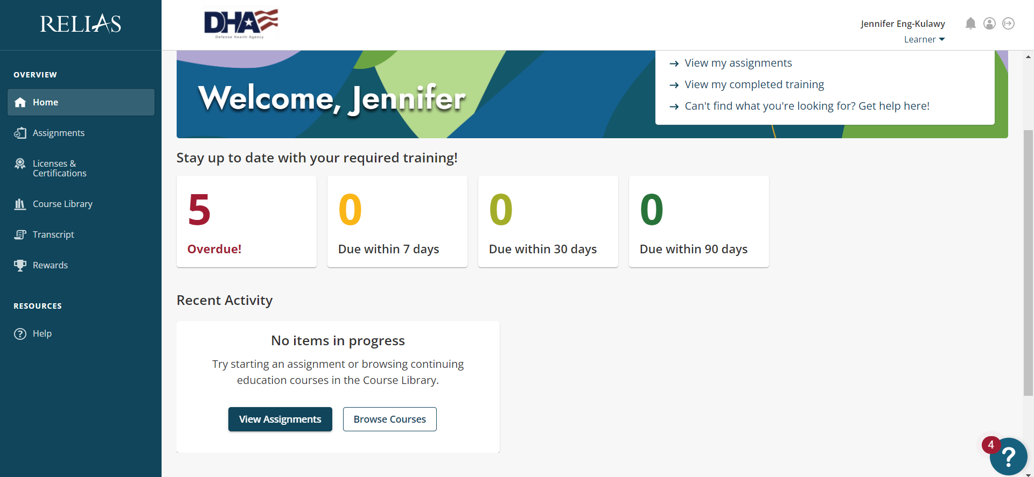

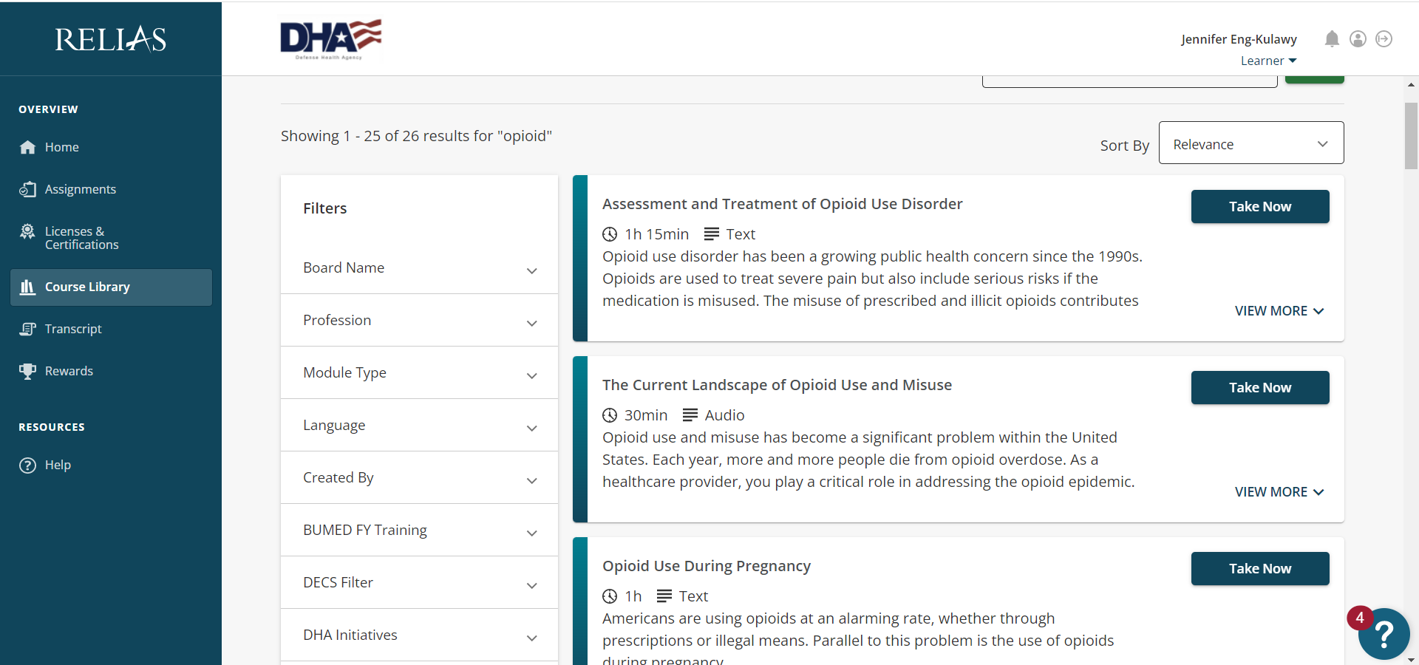

Choose Accreditation Council for Continuing Medical Education (ACCME)

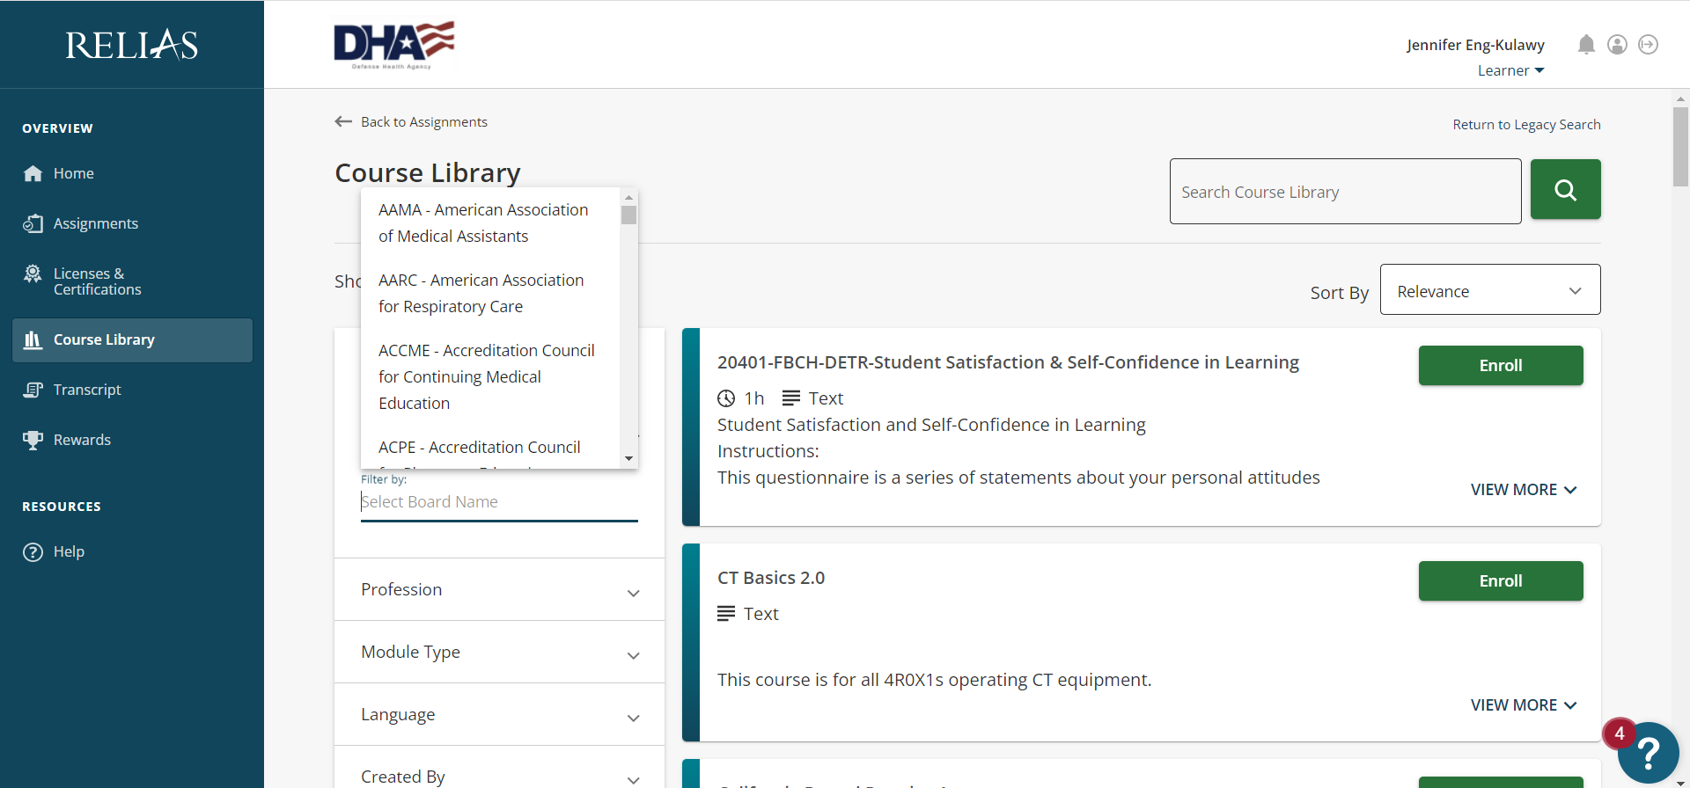
Search for Opioid
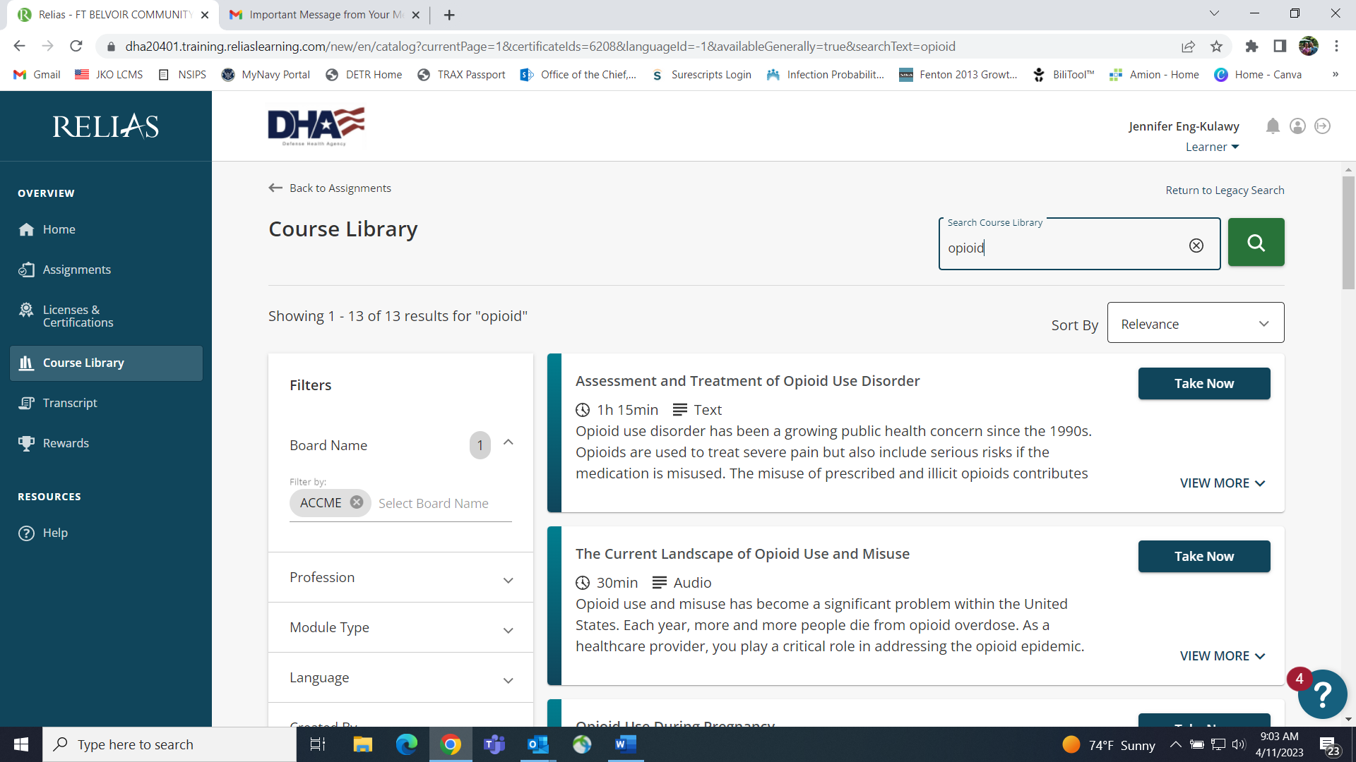

Enroll in any number of courses that refer to training on opioid or other substance use disorders.

