Using Social Media to Build Your Professional Influence
Joel Schofer, MD, MBA, CPE, FAAEM, FAAPL
Captain, Medical Corps, US Navy
Navy Bureau of Medicine and Surgery

Key Takeaways

- Social media can be used to establish yourself as a thought leader and expert, advancing your career.
- This can be done at low cost and with varying amounts of additional time dedicated to it.
- The key is to find something that you are already doing or want to do that, if broadcast to others via social media, could benefit other people.

Two Personal Examples

- Emergency Ultrasound E-mail Listserve and Blog
  - Used Pubmed to e-mail me any new paper with the word “ultrasound” in it.
  - Screened the abstracts for those relevant to emergency ultrasound.
  - E-mailed the abstracts out to anyone who wanted them and automatically posted them on a blog.
  - At peak over 600 clinicians were receiving the e-mails world-wide.
- MCCareer.org - Joel Schofer’s Career Planning Blog
  - Took a job where I was responsible for helping others manage their career.
  - Realized that there were great resources already in existence for this, but that they were scattered about the internet and in personal files.
  - Solved this problem by consolidating it all in one place.

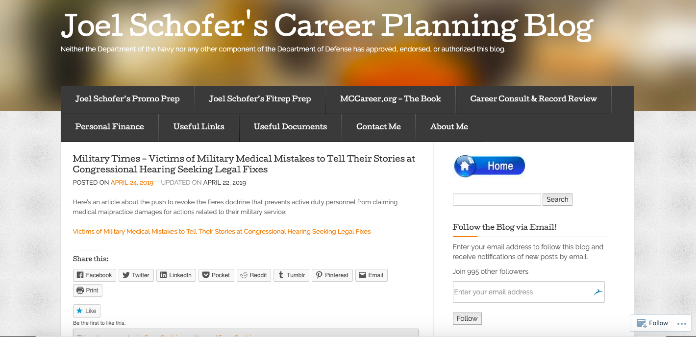

Benefits of Social Media Activity

- As you develop a following, you build a brand as an expert.
- Translate that expertise into positions of leadership and opportunities:
  - Ultrasound listserve:
    - Secretary/Newsletter Editor of American College of Emergency Physicians Emergency Ultrasound Section
    - Editor-in-Chief of SonoSite Journal Watch
  - MCCareer.org Career Planning Blog
    - Navy Emergency Medicine Specialty Leader
    - Deputy Medical Corps Chief
    - Multiple speaking opportunities throughout Navy Medicine
- Benefit by helping others. People will seek you for advice and mentorship and thank you for your efforts.
- Being internet famous.

Proceed with Caution

- Make sure you follow your employer’s social medical policy!
- Once you start producing content, you need to do so regularly. Walk before you can run.
- Automate any processes you can. Post in one place and have it auto-post on other sites.
- The Danger of Social Media for Healthcare Professionals -(https://www.healthecareers.com/article/career/social-media-healthcare-professionals)

Resources for Further Information

- Successful Blogging: 10 Steps to Building and Growing a Website - https://www.physicianonfire.com/blog/
- Do You Even Blog - https://doyouevenblog.com/
- Twitter for Physicians - https://www.kevinmd.com/blog/2012/06/started-twitter-primer-doctors.html
- Tips to Establish Yourself as a Physician Thought Leader - http://www.priviahealth.com/blog/tips-to-establish-yourself-as-a-physician-thought-leader/
- How to Use Social Media in Healthcare: A Guide for Health Professionals - https://blog.hootsuite.com/social-media-health-care/

Contact Me for Questions

- E-mail - jschofer@gmail.com
- Website - MCCareer.org
- Facebook - https://www.facebook.com/MCCareer.org/
- Twitter - @MCCareer_Org

Disclaimer

The views expressed in this handout are those of the author and do not necessarily reflect the official policy or position of the Department of the Navy, Department of Defense, or the United States Government.

